1) What are the different types of NoSQL databases? Give some example.

NoSQL database can be classified as 4 basic types:

1. Key value store NoSQL database 🡪 Redis
2. Document store NoSQL database 🡪 MongoDB 🡪 Does not support transaction like RDMS.
3. Column store NoSQL database 🡪 Cassandra
4. Graph base NoSQL database 🡪 Neo4j

There are many NoSQL databases. MongoDB, Cassandra, CouchBD, Hypertable, Redis, Riak, Neo4j, HBASE, Couchbase, MemcacheDB, Voldemort, RevenDB etc. are the examples of NoSQL databases.

2) What is the advantage of MongoDB?

1. Data Durability:- Failure of one server does not affect data loss due to replica set.

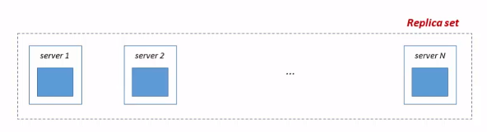

2. Horizontal scaling:

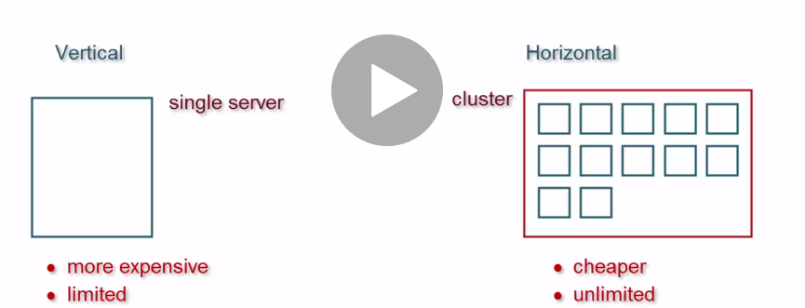 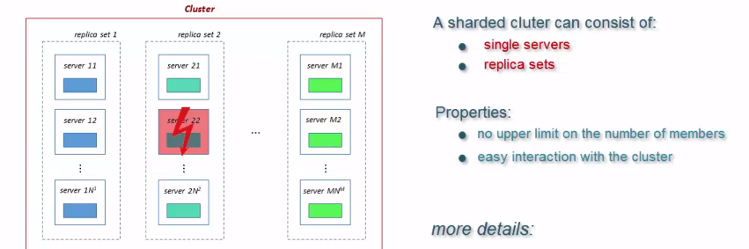

* Vertical Scaling: Vertical Scaling increases storage and CPU resources for expanding the capacity.
* Horizontal Scaling: Horizontal Scaling splits the datasets and circulates the data over multiple shards or servers.

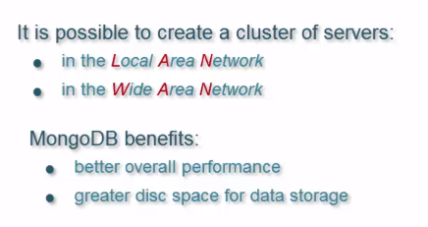 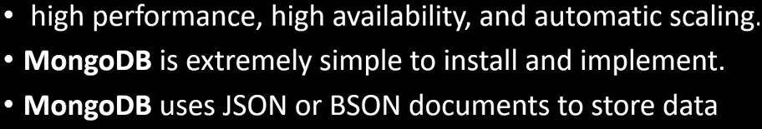

3. Dynamic Schema: we can add multiple features in individual document which is not affect others inside a collection.

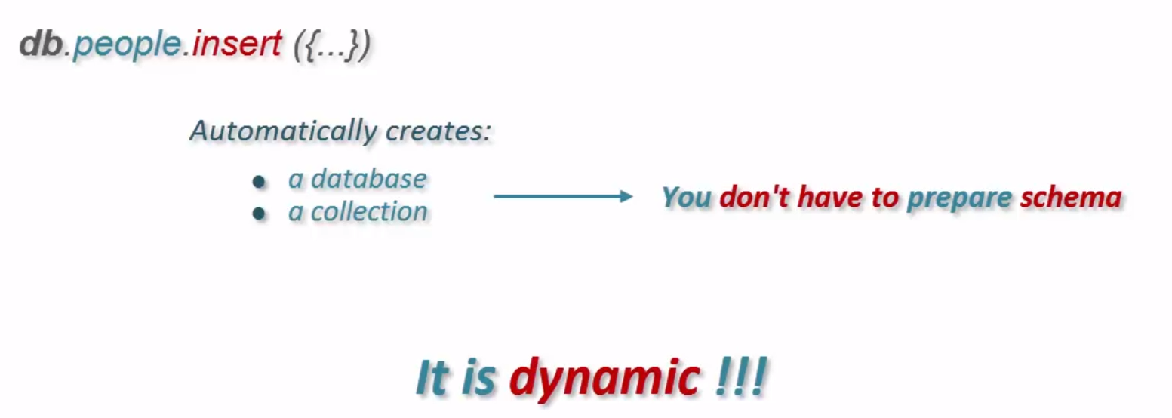

3) What is the disadvantage of MongoDB?

Does not support transaction like RDMS.

4) What are the components of MongoDB?

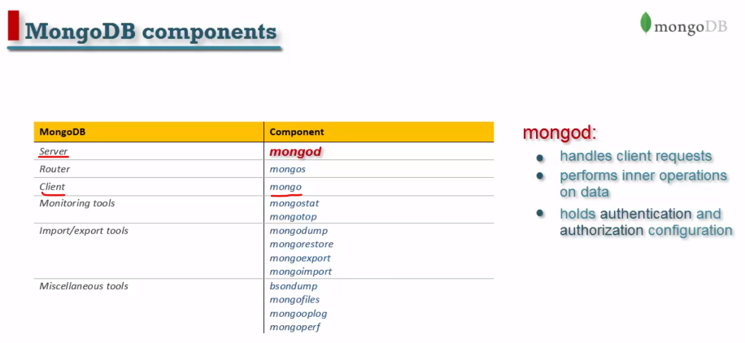

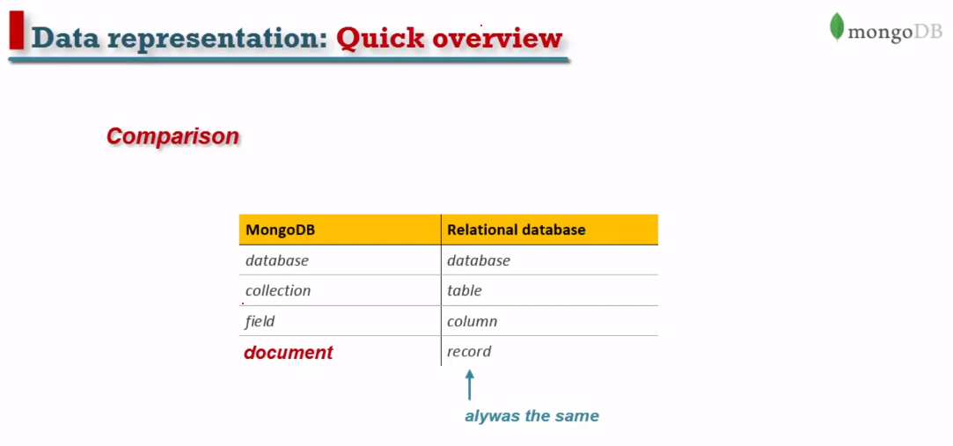

5) Can you achieve primary key - foreign key relationships in MongoDB?

We can achieve primary key-foreign key relationship by embedding one document inside another. For example: An address document can be embedded inside customer document.

11) Explain the structure of ObjectID in MongoDB.

ObjectID is a 12-byte BSON type. These are:

4 bytes value representing seconds

3-byte machine identifier

2-byte process id

3-byte counter

13) What are Indexes in MongoDB?

In MondoDB, Indexes are used to execute query efficiently. Without indexes, MongoDB must perform a **collection** scan, i.e. scan every document in a collection, to select those documents that match the query statement. If an appropriate index exists for a query, MongoDB can use the index to limit the number of documents it must inspect.

14) By default, which index is created by MongoDB for every collection?

By default, the**_id** collection is created for every collection by MongoDB.

15) What is a Namespace in MongoDB?

Namespace is a concatenation of the **database** name and the **collection** name. Collection, in which MongoDB stores BSON objects.

15) What is a Document in MongoDB?

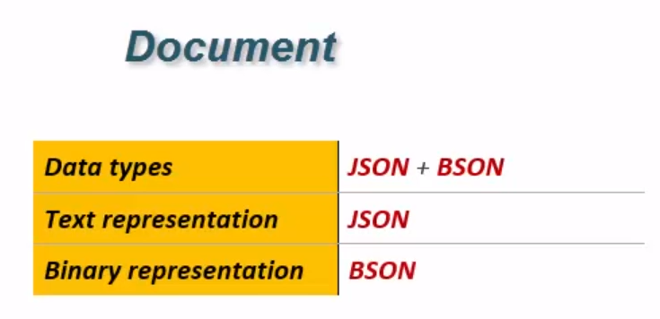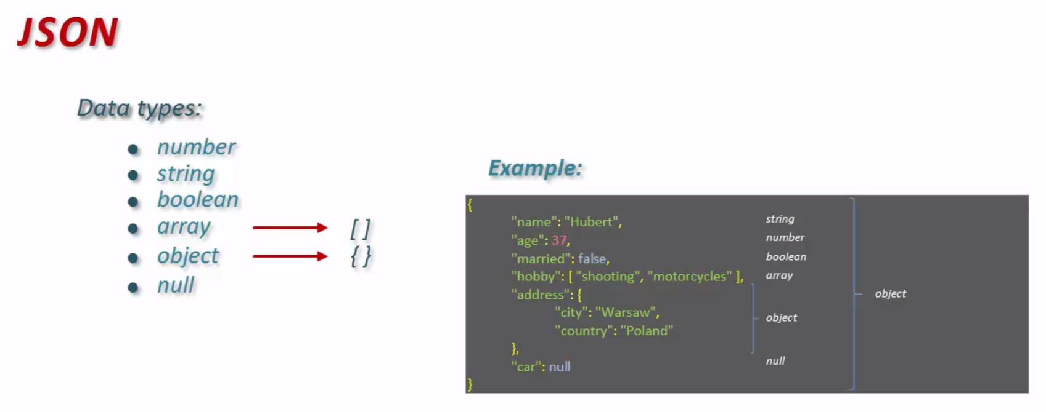

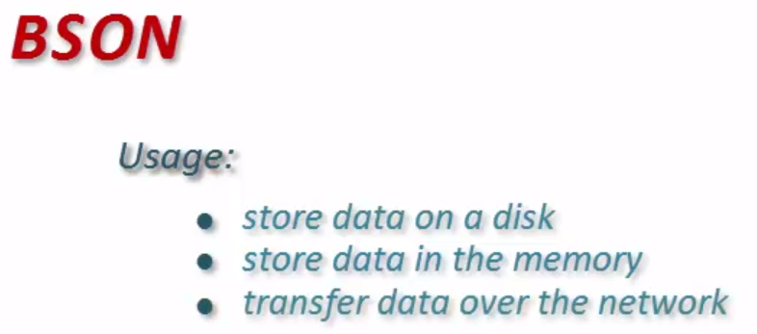 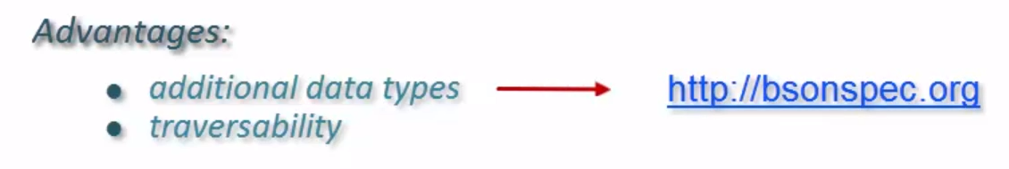

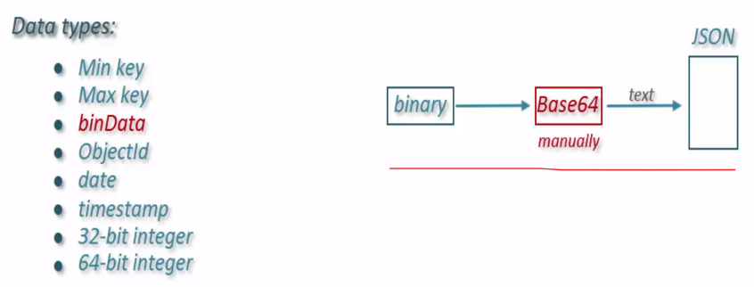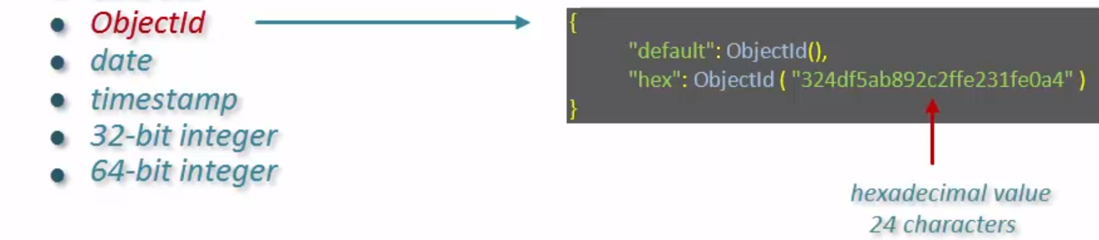

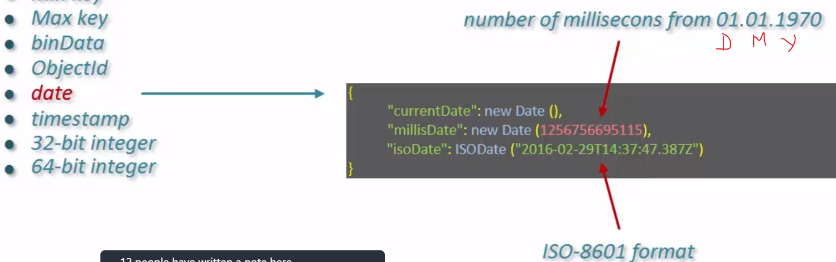

16) What are a Collections in MongoDB?

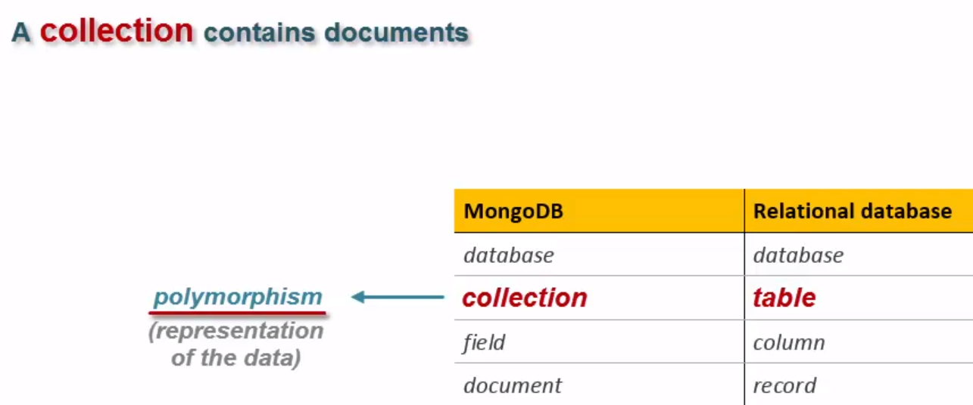 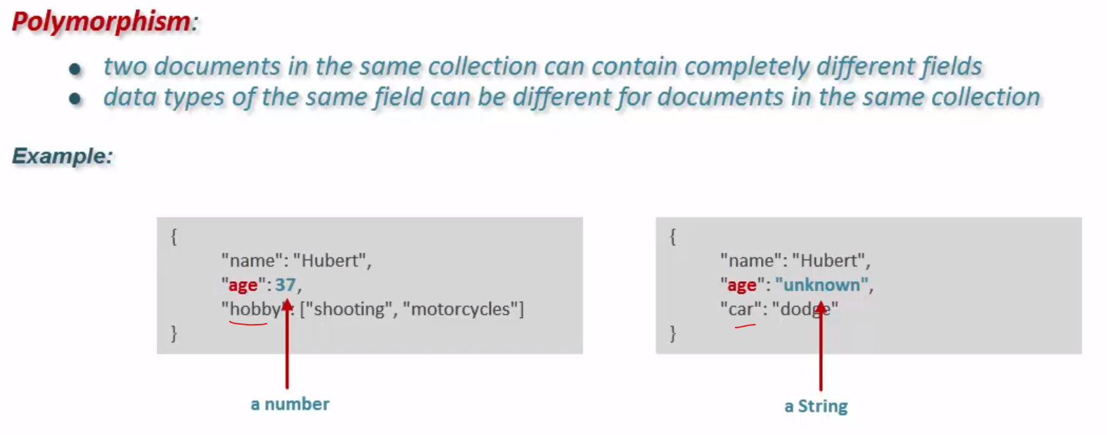

17) Insert Document

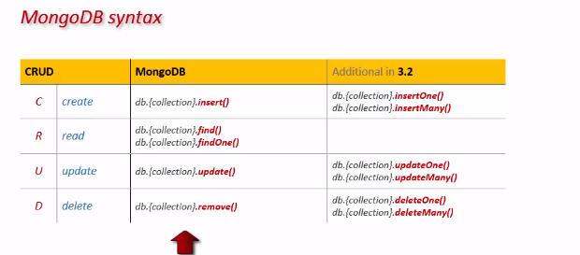

Insert Document Restriction: -

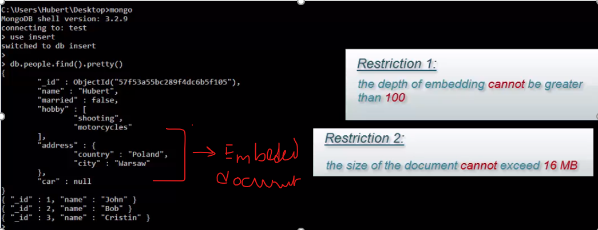

Find method definition: -

1. Difference between find() & findOne()?

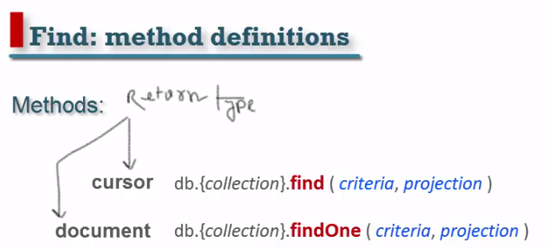

**18) MongoDB Cursor?**



* When call find() then the object that represented cursor is created but not the cursor in the MongoDB server.
* The cursor in MongoDB server is created when we execute first method to interact with the data. Eg: - **hasNext**()
* MongoDB server it sends first **batches (101 Document or 1 MB data whichever is the smaller) of data**
* Calling **next()** iterate all the document of batch from the object that represented cursor and send request to the server for the next batch.
* Now server send up to 4 MB of data for each batch.
* When server send the last batch, it gets closed automatically.

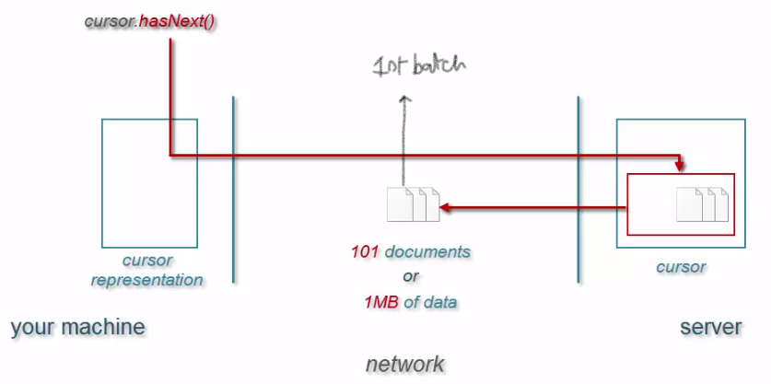 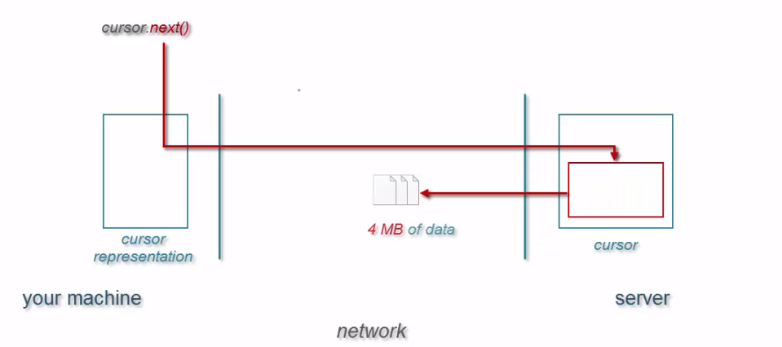

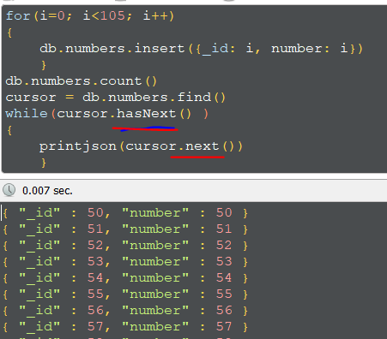

**19) MongoDB Operator?**

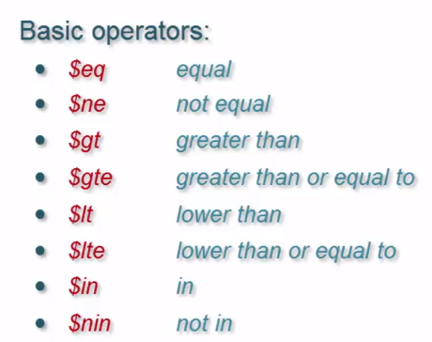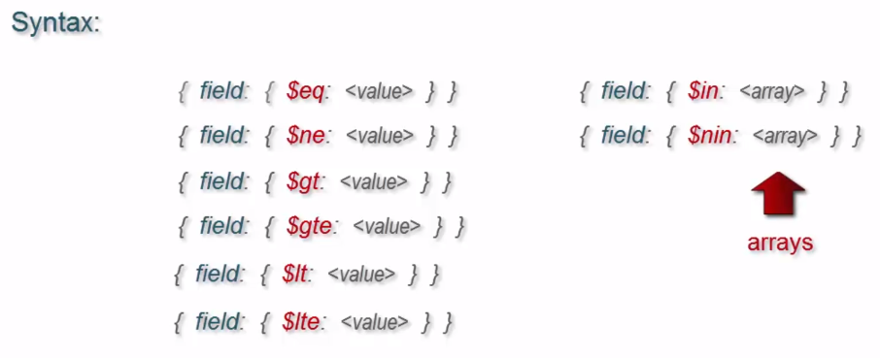

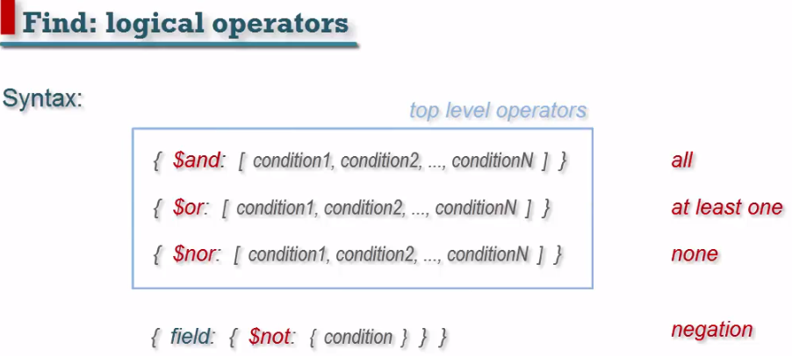

**20) MongoDB Document structure?**

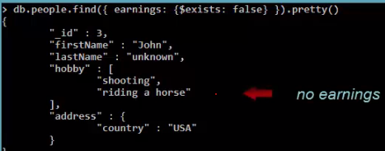 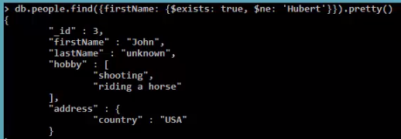 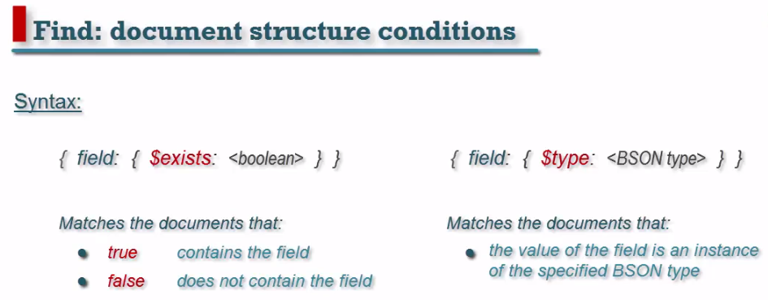

$type: ‘array’ vs $type: ‘string

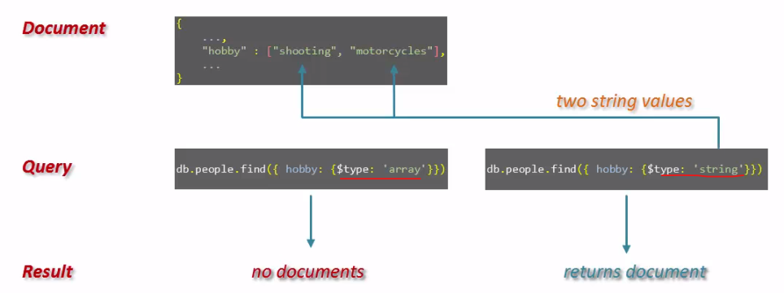

**21) MongoDB Array?**

**22) MongoDB Projection?**

In MongoDB, projection means selecting only the necessary data rather than selecting whole of the data of a document. If a document has 5 fields and you need to show only 3, then select only 3 fields from them.

Can include and exclude fields from embedded document.

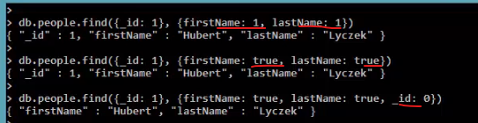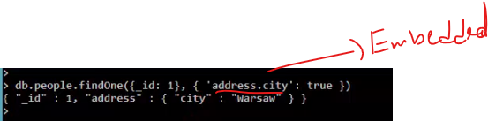

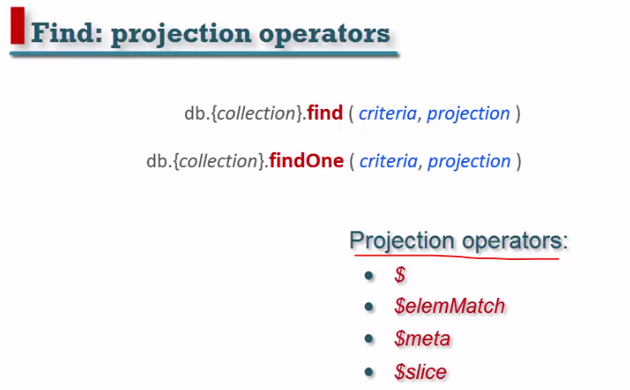

**23) MongoDB GridFS?**

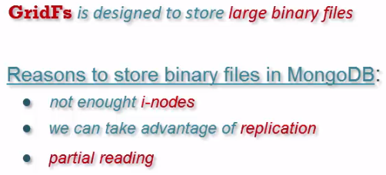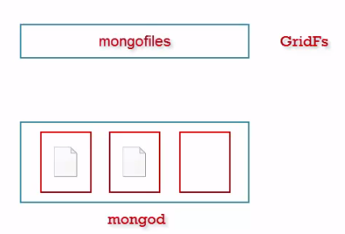

It is a functionality that built on the standard MongoDb database. We can decide that which database GridFs data can be store.

**Mongofiles** define GridFs data for more than 16MB

 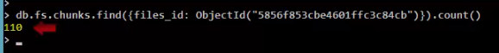

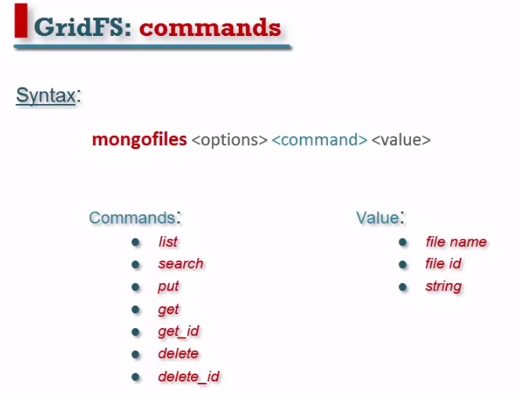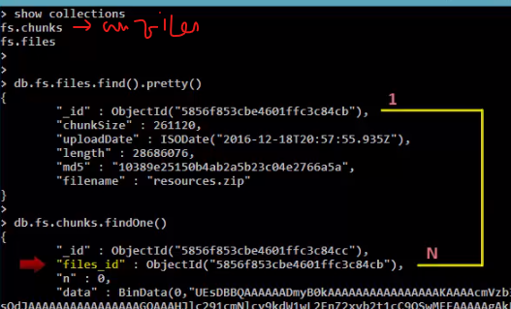

**List, search**, **get_id**  
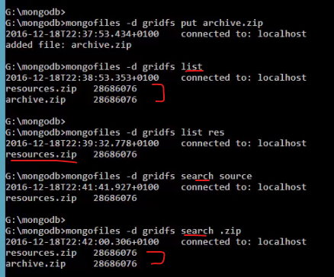 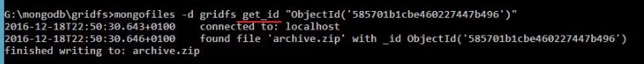

**23) MongoDB storage engines?**

* Internal component of the database.
* It is used to communicate with Hardware.
* It is finding how to data store in disk, memory

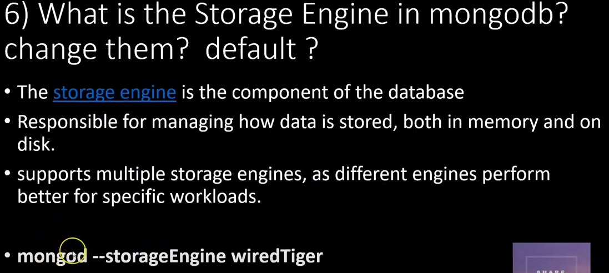 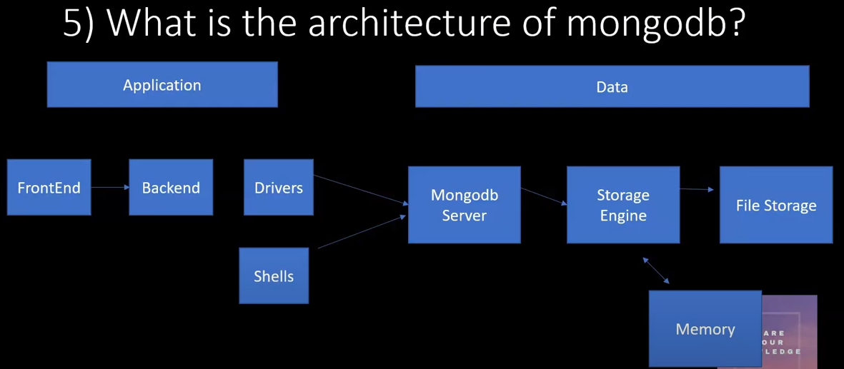

**Difference between Wired Tiger and MMAPv1**

**1.**

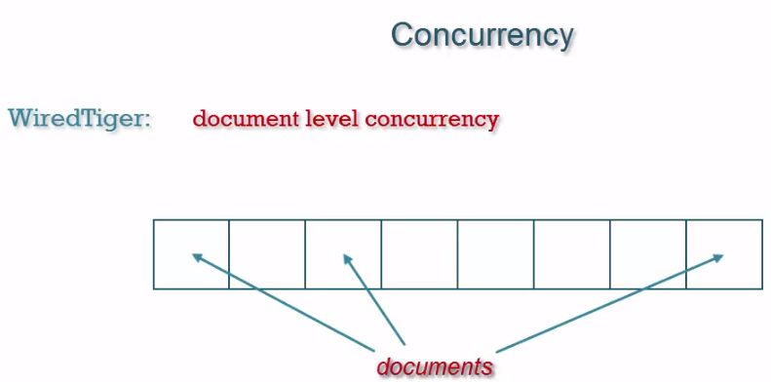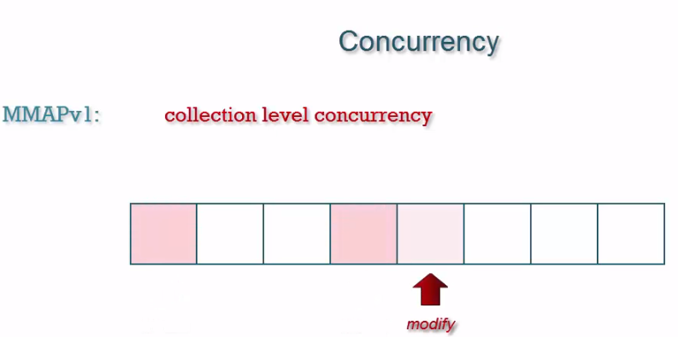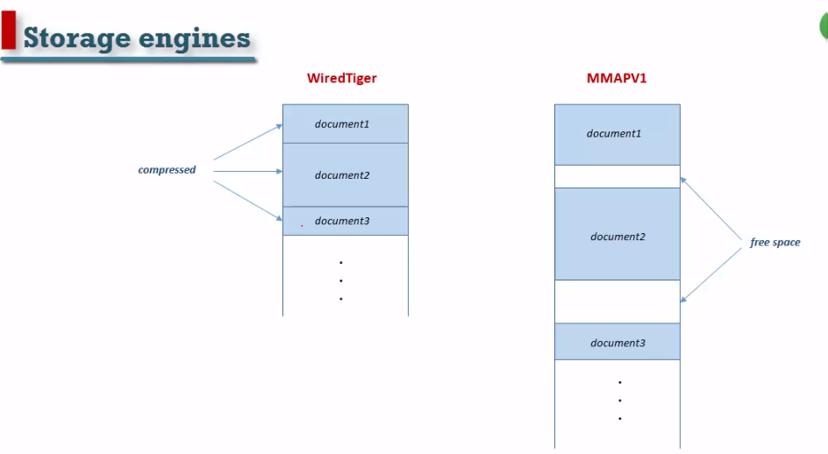

Multiple documents update same time.Only update one document at a time.

1. **WiredTiger** documents are stored in compressed manner. No free space available. Utilize disc space properly. But it has higher CPU usage.

MMAPv1 **free space are available**. Not efficiently use disc space.

1. Zlib usage more CPU and compressed is better than snappy.

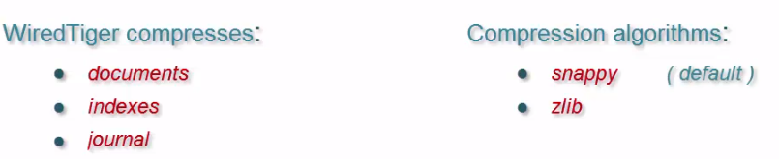

**24) MongoDB journal?**

It is provided data durability in the risk database failure. It stores under {dbpath}/journal directory.

* Every 50ms data change in memory written in journal files.it is called durable data. If db failure, then data can be read from the journal file to the db files.
* Now data files are updated in 60ms or 2GB of journal data from journal files.
* By Write concern can avoid the data failure.

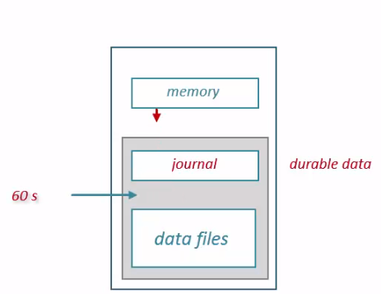 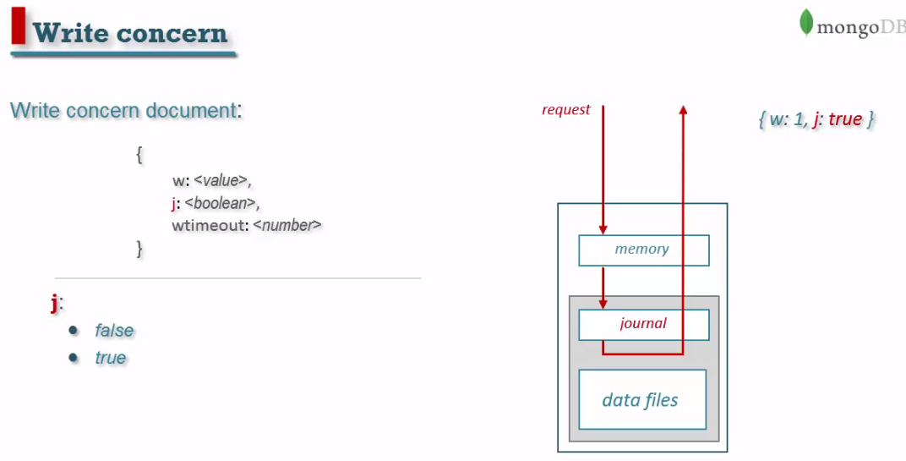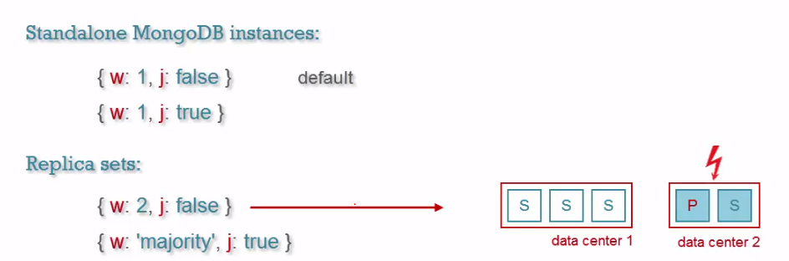

**25) MongoDB Collections?**

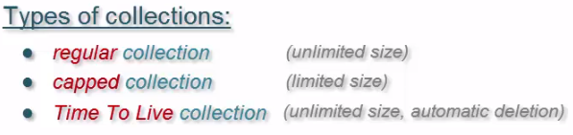 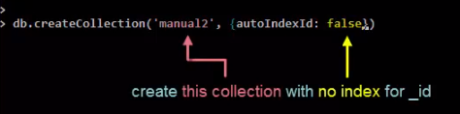

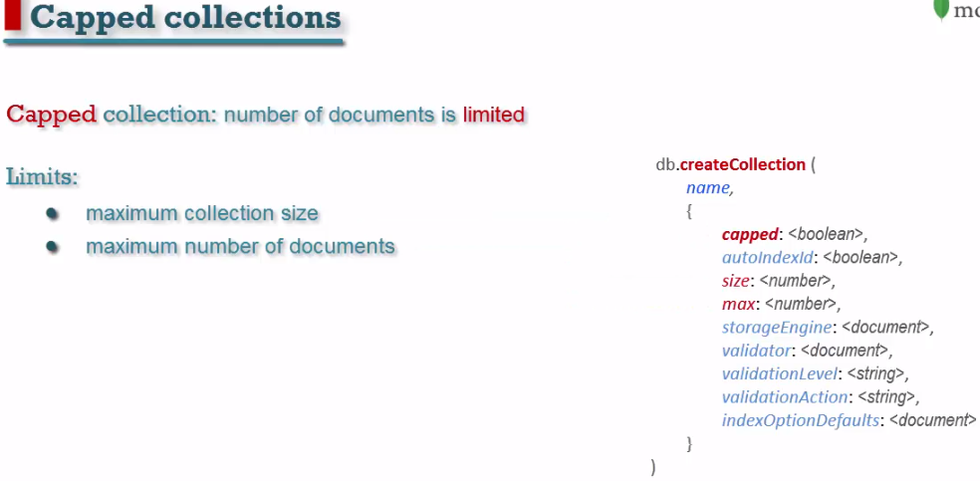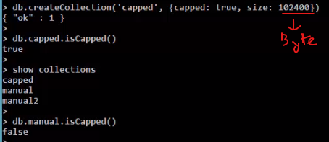

**Insert document in capped and manual collections**

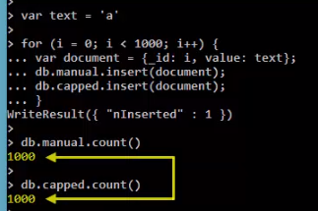**Check document status**

**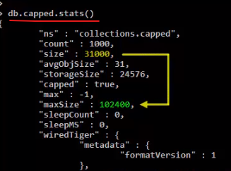  
 Limitation: -**

* Cannot **remove** document from a capped collection.
* Can update capped collections document if change the size of the document is same.

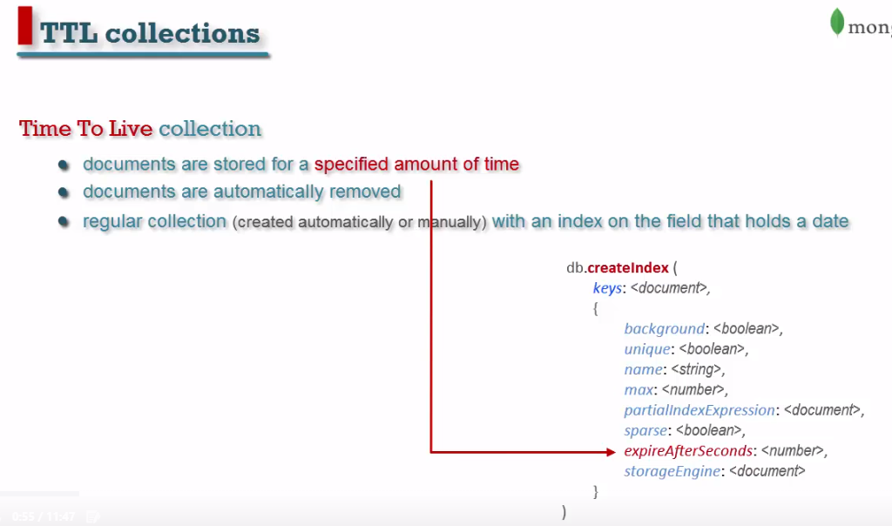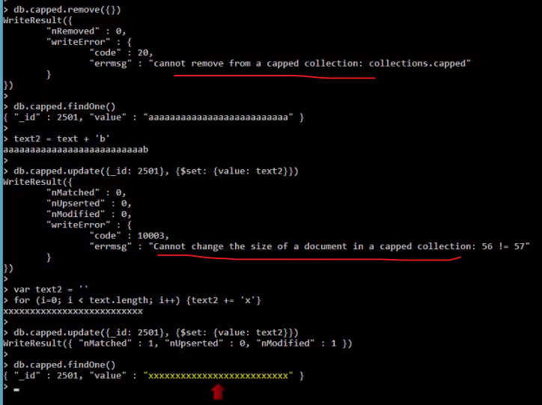  
 **Column(expireAfterSeconds) modification in TTL collections:**

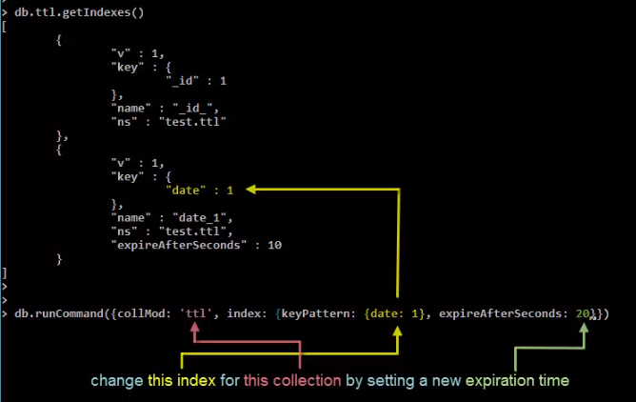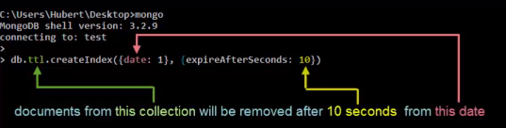 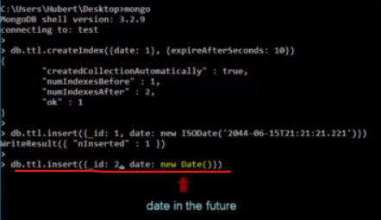

**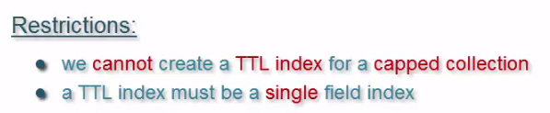  
26) MongoDB Validation?**

**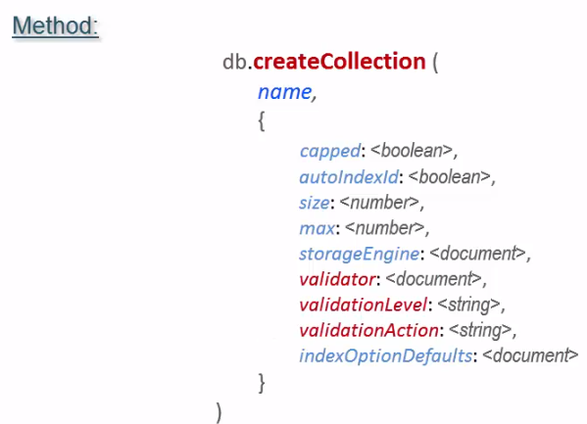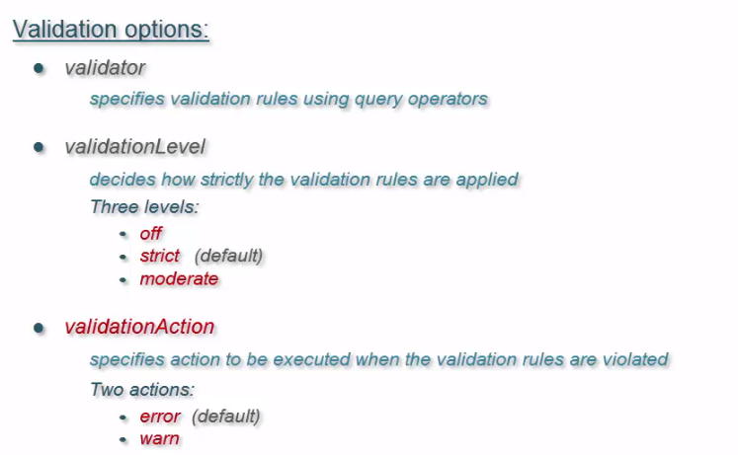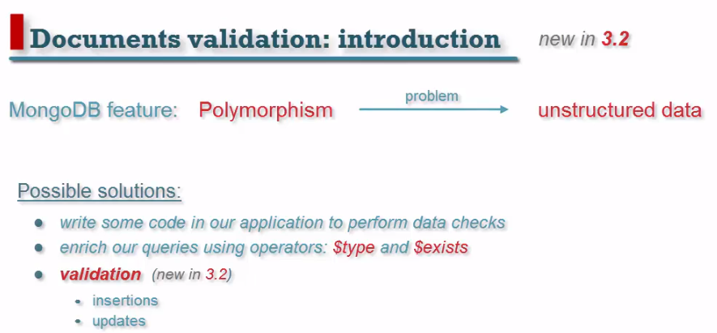  
1. Validator: -**

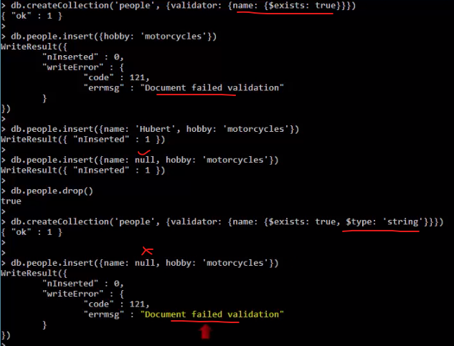**Handling Null string: -**

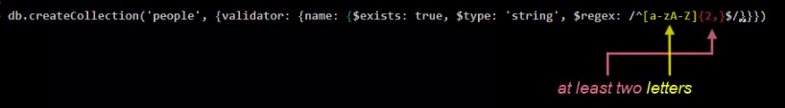

**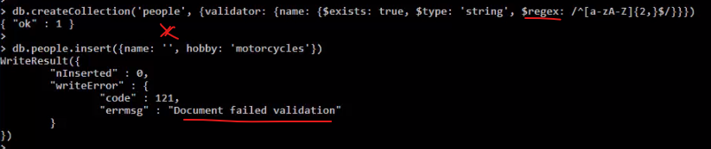  
2. Validation Level: - Validation = Enter first name and Last name or nick name. Log file mongod –dbpath D:\mongodb\db**

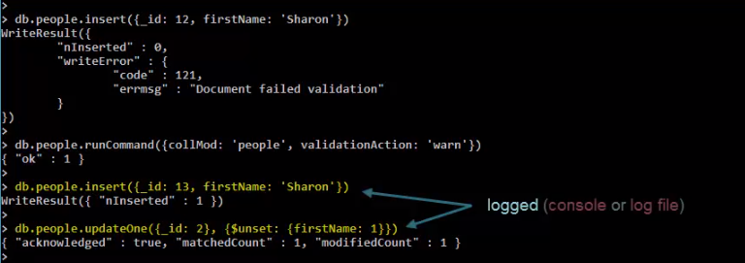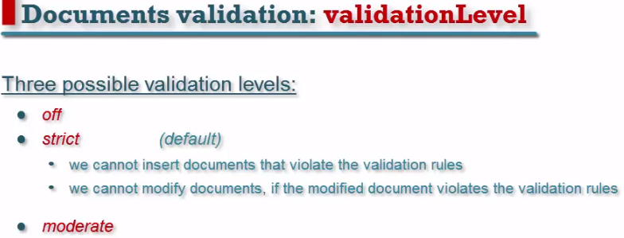

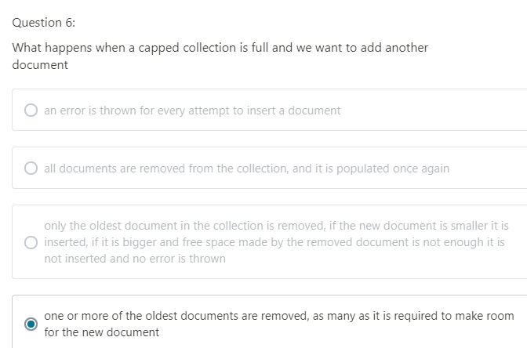

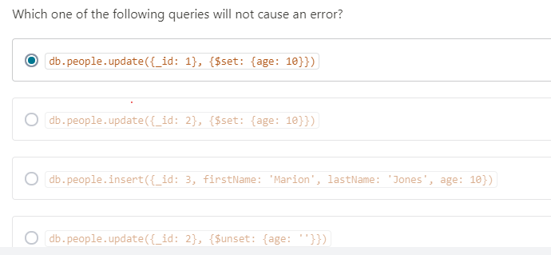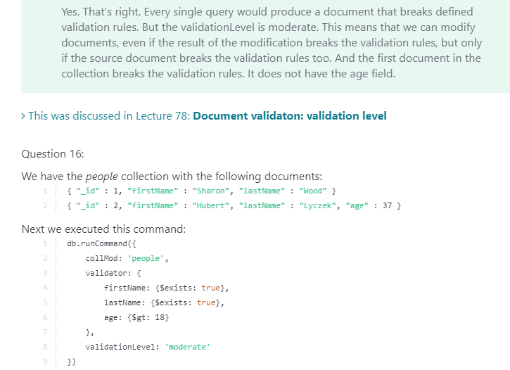

**26) MongoDB Index?**

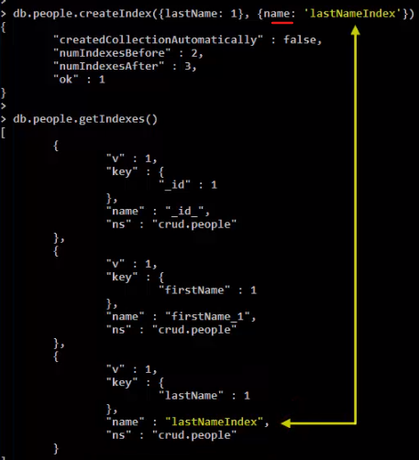 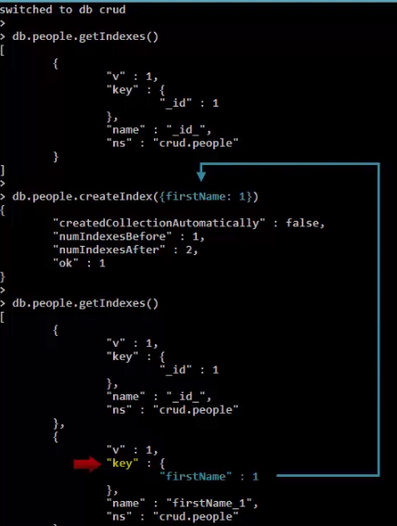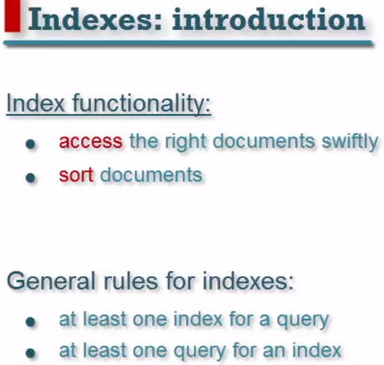

Use explain() to identify whether a query uses index or not?

Use hint() to specify index within a query

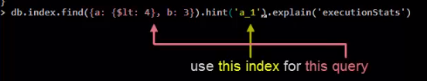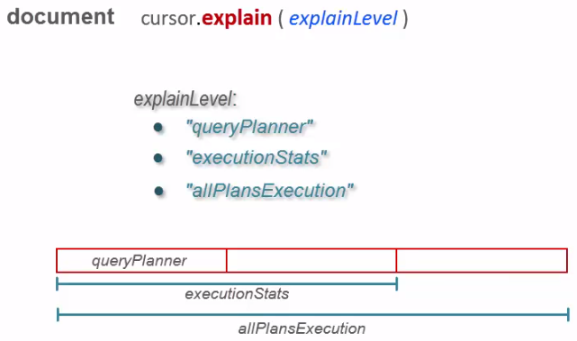

**Single Field Index: sorting:**

An index is used not only querying data but also sort data.

1. *We have 3 indexes as _id:1, a: 1(Ascending), b: -1(Descending)*

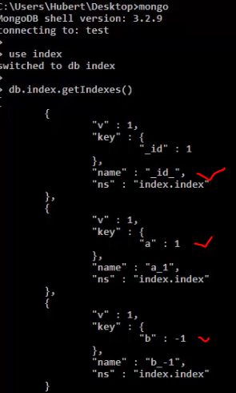

Query : 

* This query has two stages: **FETCH** & **IXSCAN.** Sorting is done as per indexing order.

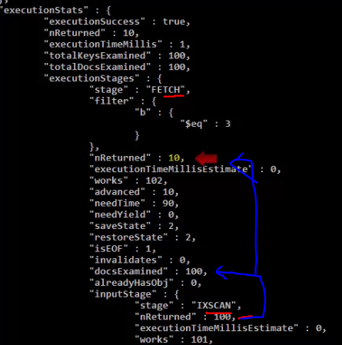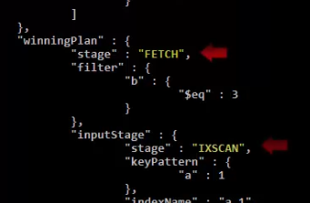

Now if sorting is defined in reverse order ( a: -1) then also indexing done only direction would be **backward**.

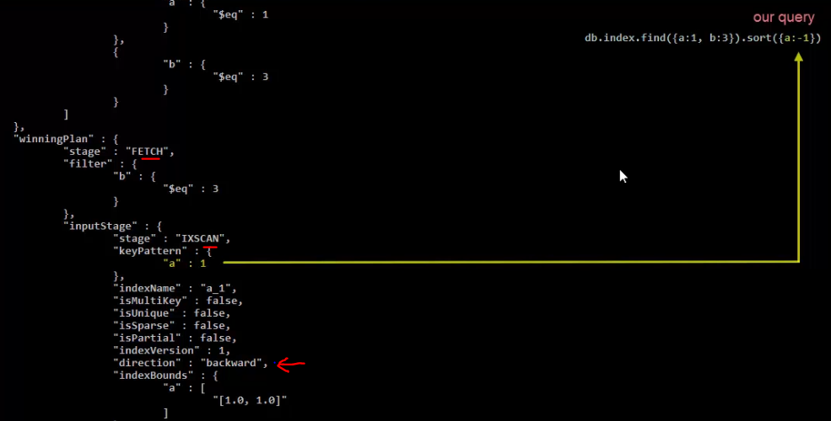

* If sorting is not mentioned in query that time index sorted its result set as per indexed **default sorting order**.

Result is sorted by index ‘b’ descending as per default index sorting.

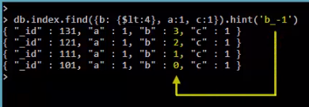  
**Index characteristic:**

* Foreground Index:-
* Foreground indexes(default) take time while data volume got increased.
* While creating index we cannot perform any query(Read, Write) on a collection.

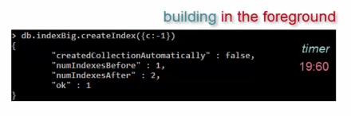

* Background Index:-
* Creating index in background can help to execute query at a same time.
* It takes much more time.
* Less compact index structure than fore ground Index.

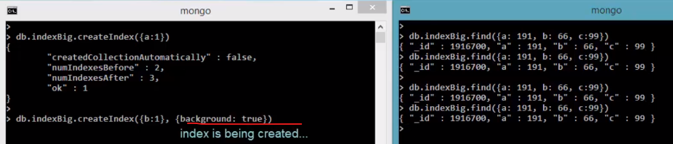

* Check index size: -

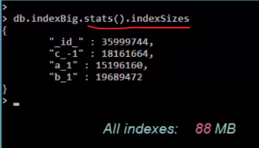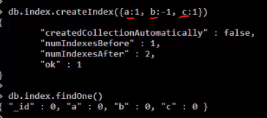

**Compound Index:**



in compound index, first field should be index

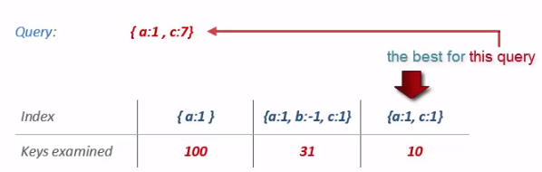 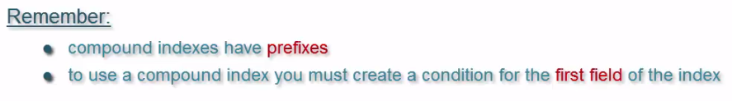

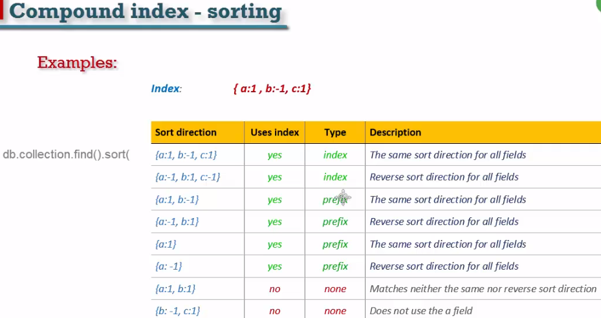

**Unique Index:**

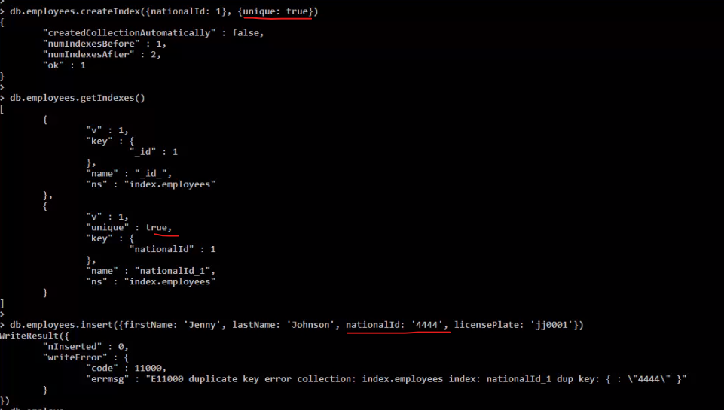

**Unique index Vs Sparse Index**

Sparse indexes only contain entries for documents that have the indexed field, even if the index field contains a null value. The index skips over any document that is missing the indexed field. The index is "sparse" because it does not include all documents of a collection. By contrast, non-sparse indexes contain all documents in a collection, storing null values for those documents that do not contain the indexed field.

**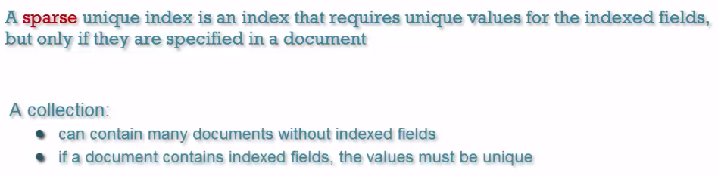  
 Compound Sparse Index:**

* Contain two or more index field with sparse is true.
* Can Insert documents without index field.

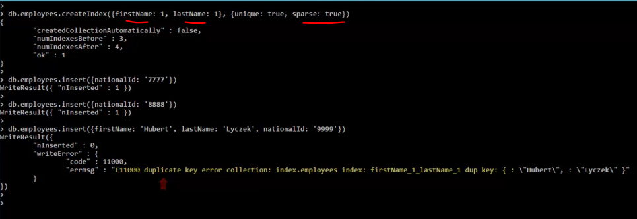

**Multikey Index:**

* Cannot insert new array value for more than one multikey index means one indexed field can contain an array.

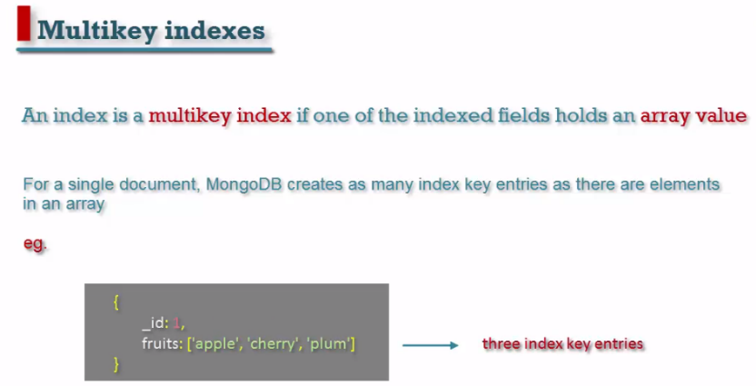

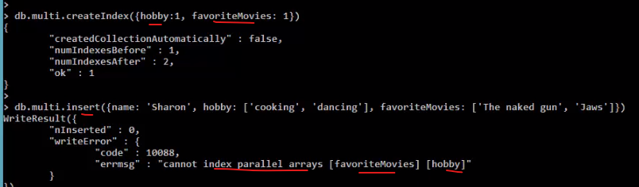

**Covered Query:**

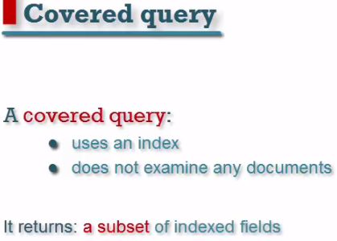

* A covered query is a query that return a result set using an index without examine any documents.
* If a query does not use index not considered as a covered query.
* It returned a subset of query field.

**Advantage**:

* Its result is very fast if index data store in a RAM.

**Scenario: 1**

Index fields are : firstname , lastname and is this below query is Covered query?

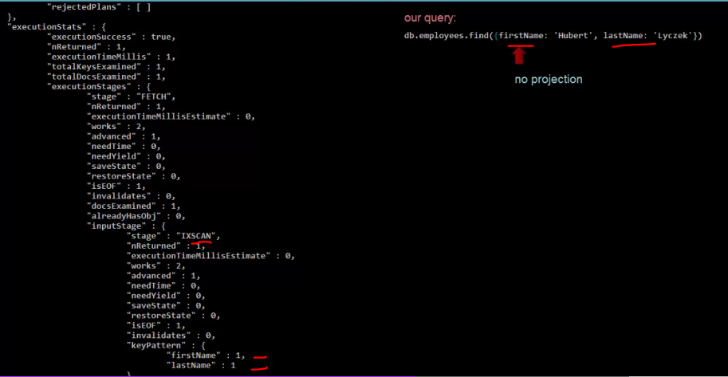**Covered Query: returned subset of query and no document examined.**

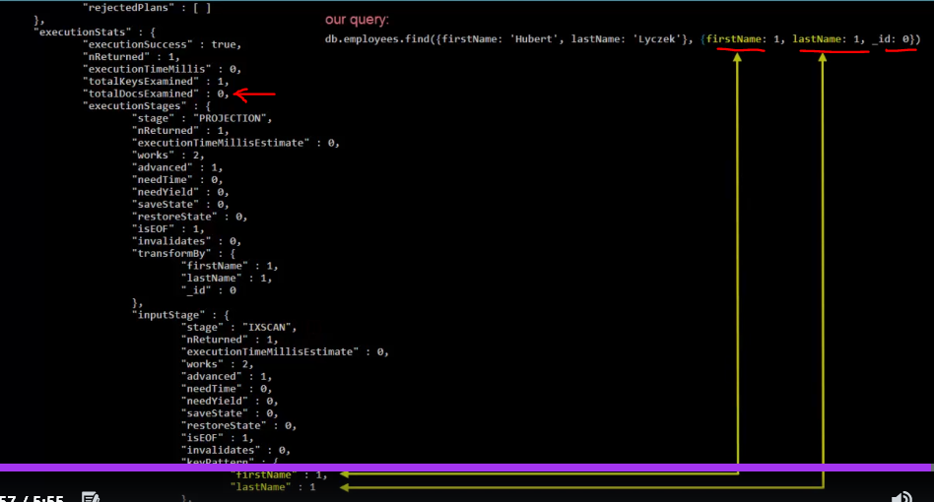  
**No, it is not. Though it is used index, but it returned all the fields not subset of index fields.**

**Special Indexes:**

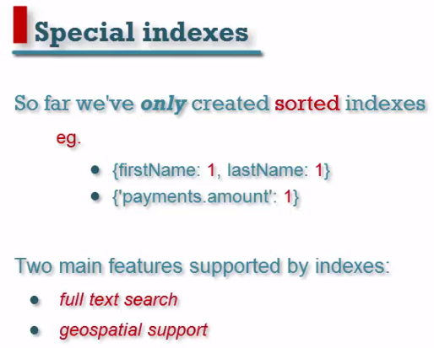

**Example:**

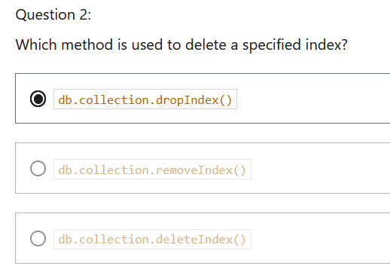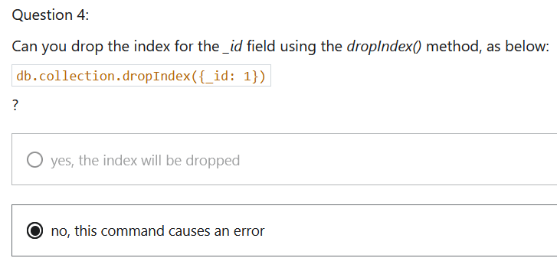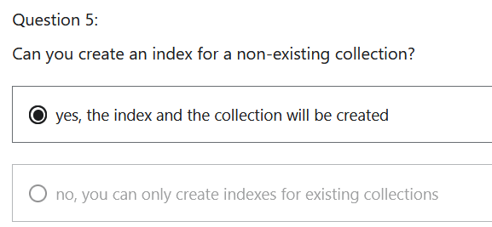

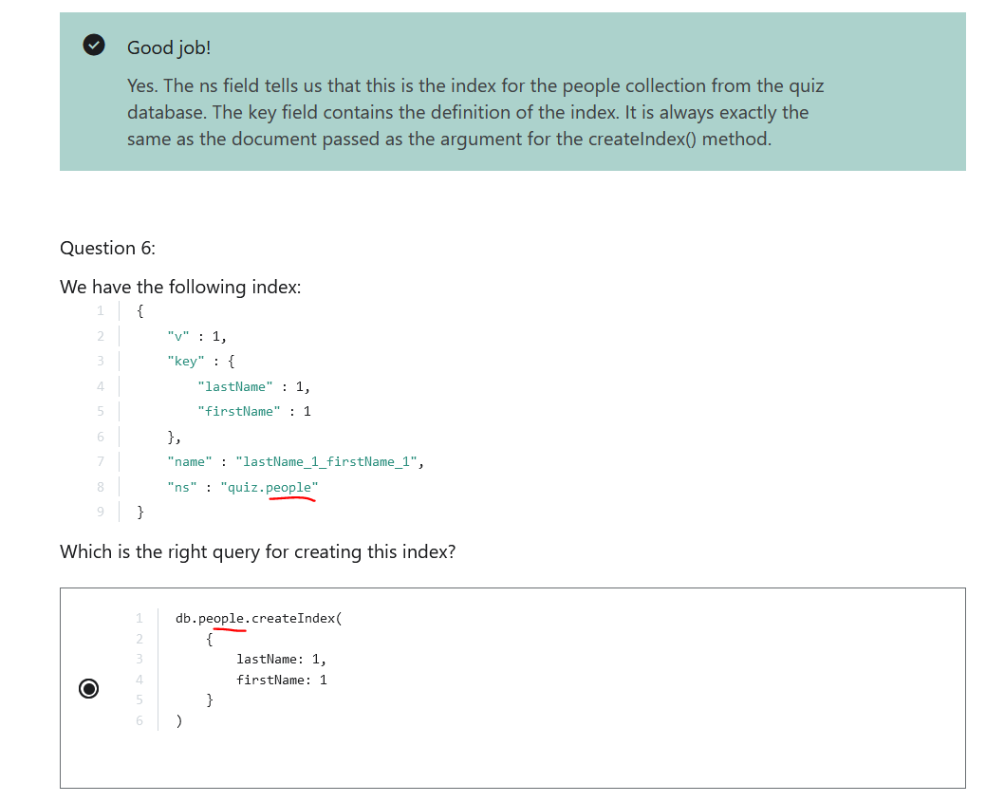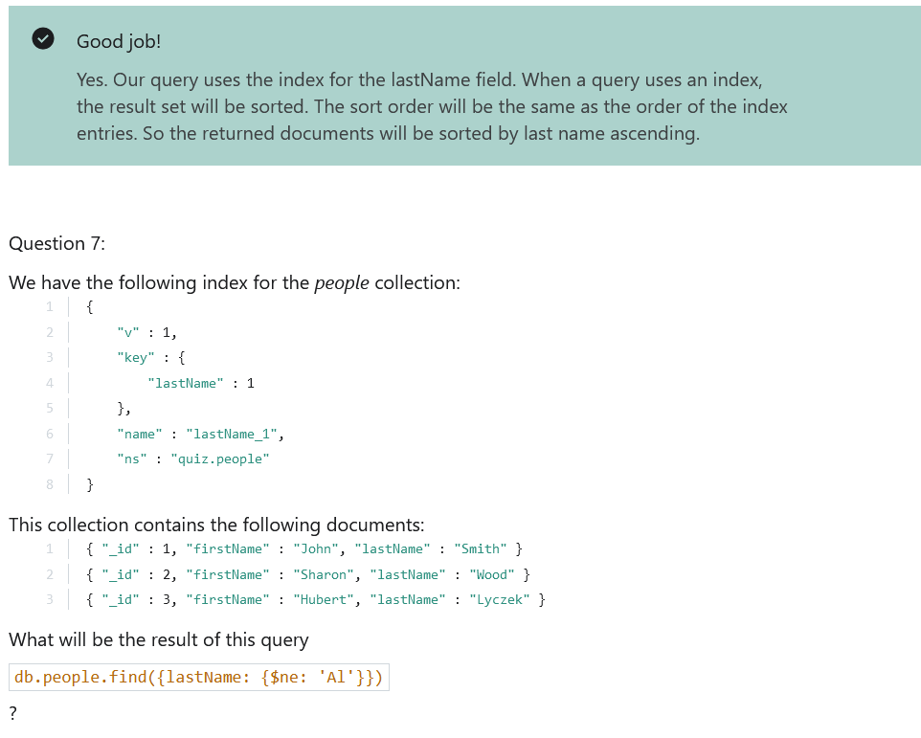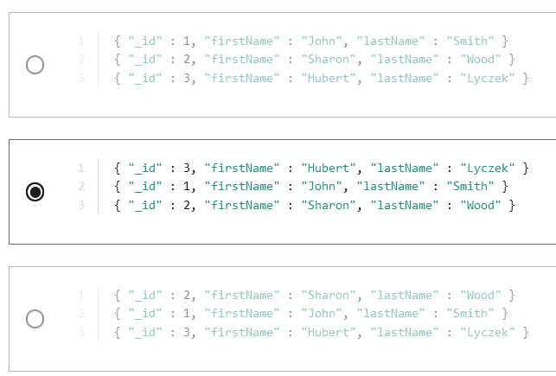

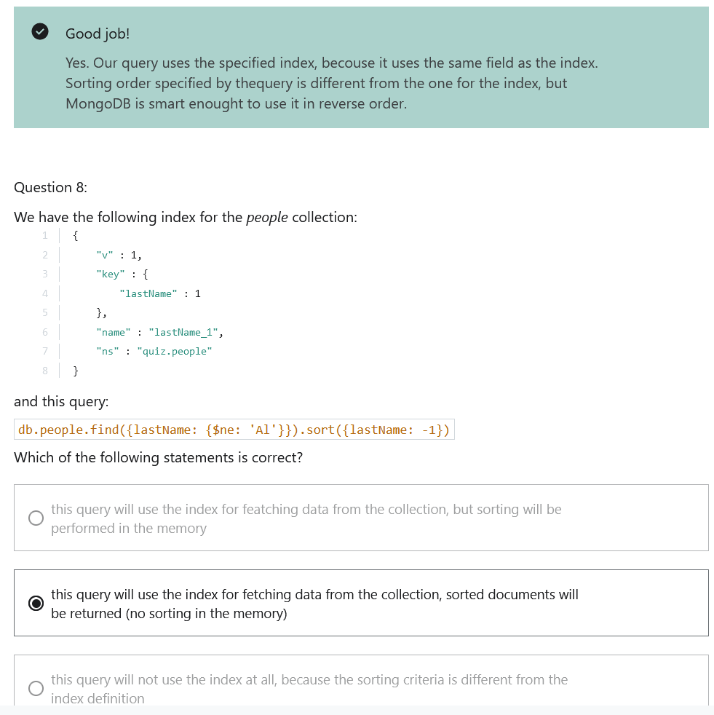 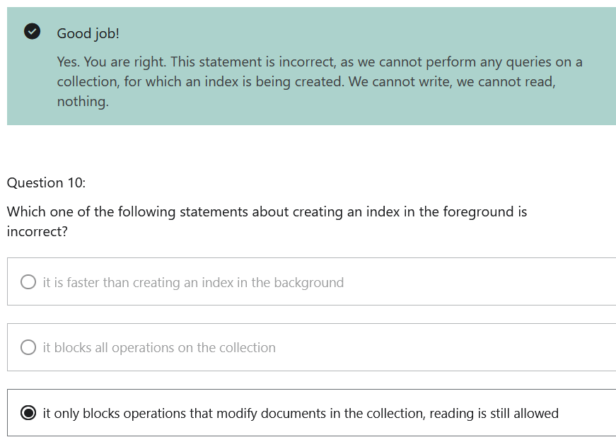 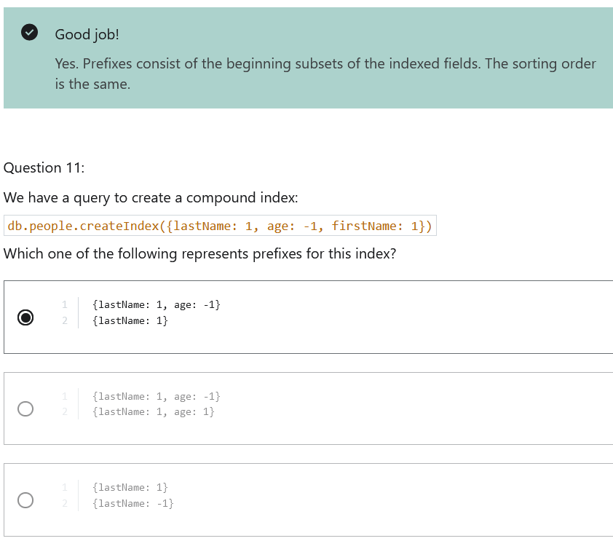 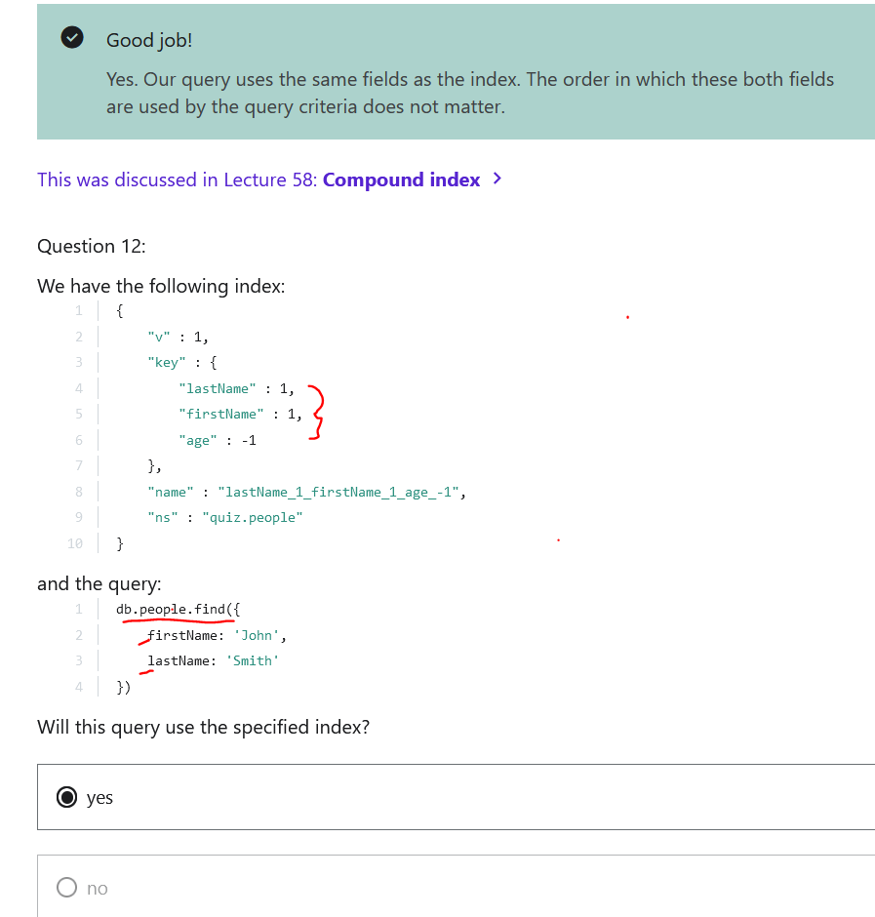

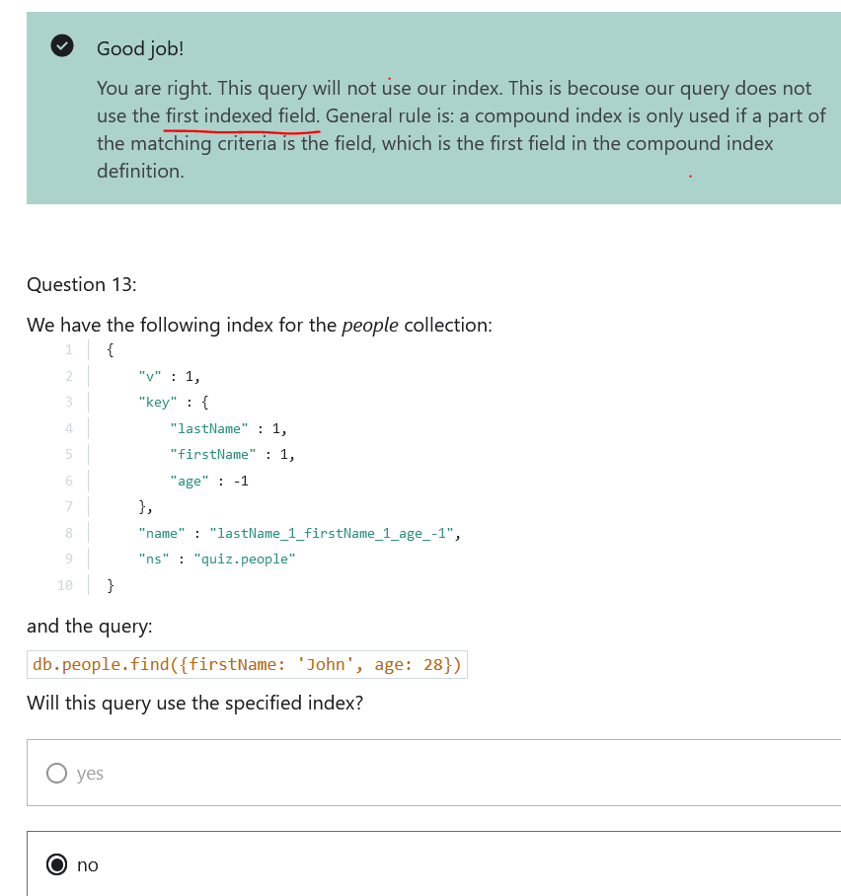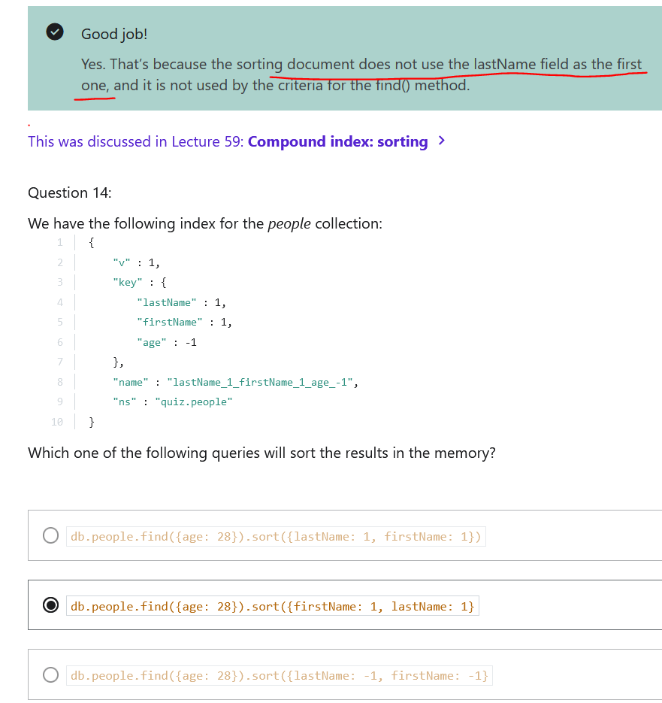

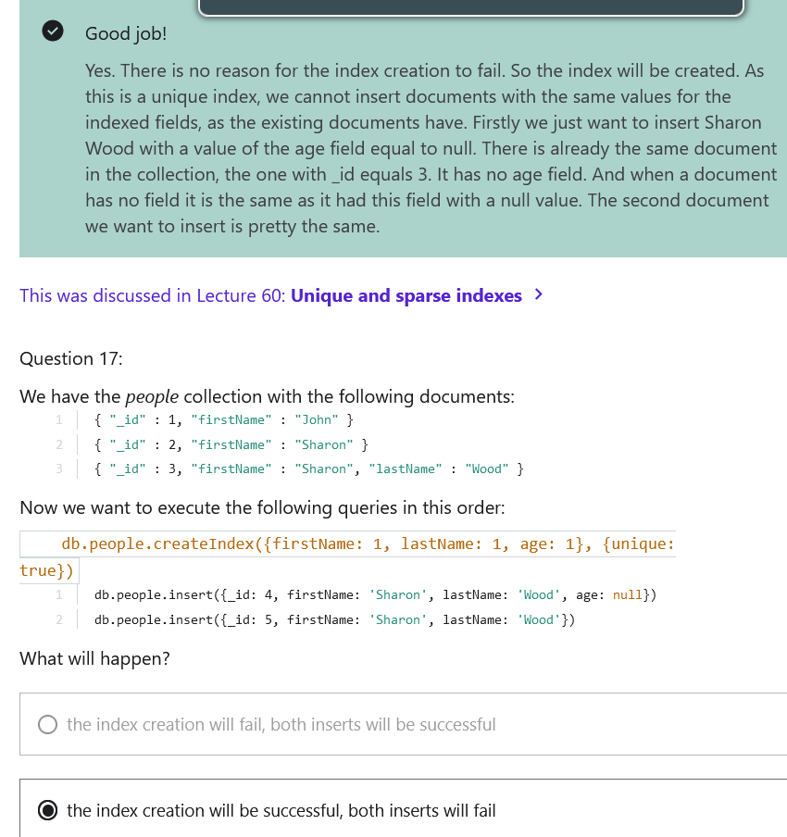

**Full Text Search:**

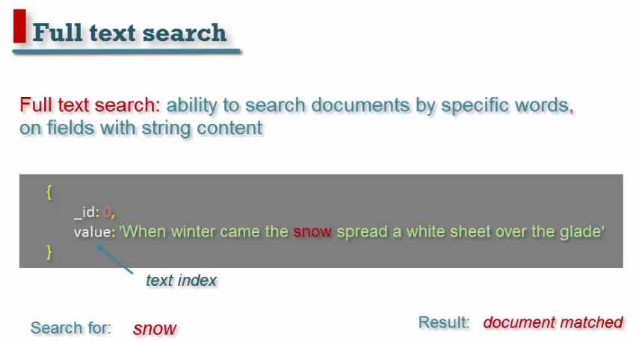 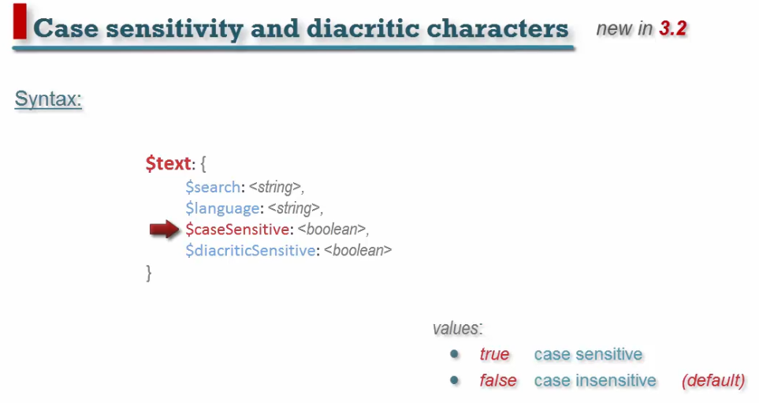 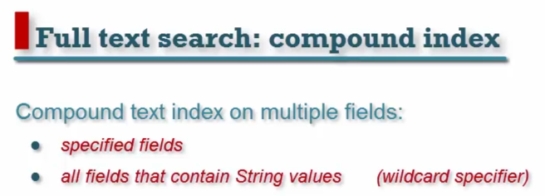 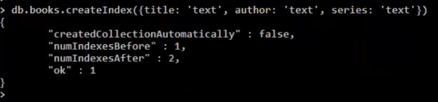

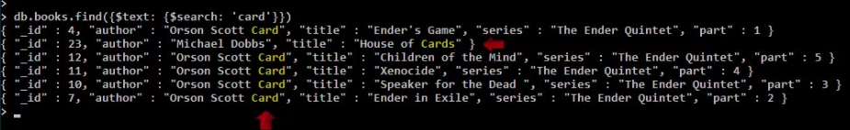 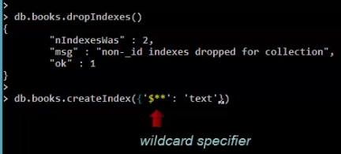

**Geospatial Support:**

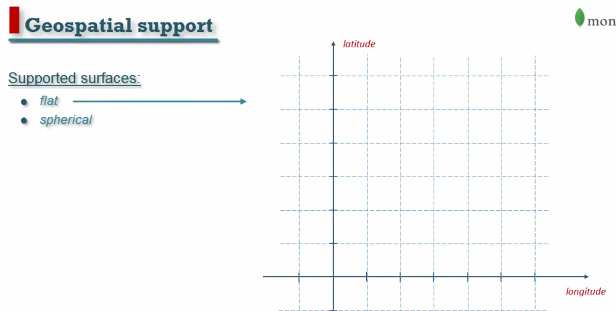

**Spherical** represent geographical coordinates.

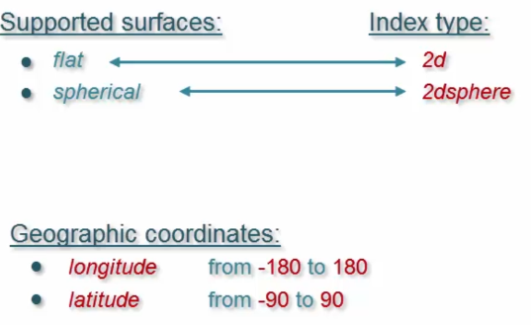

**Difference between them:**

For 2d, distance between them is not zero represent two different points.

For 2dsphere, it shows geographical coordinates.

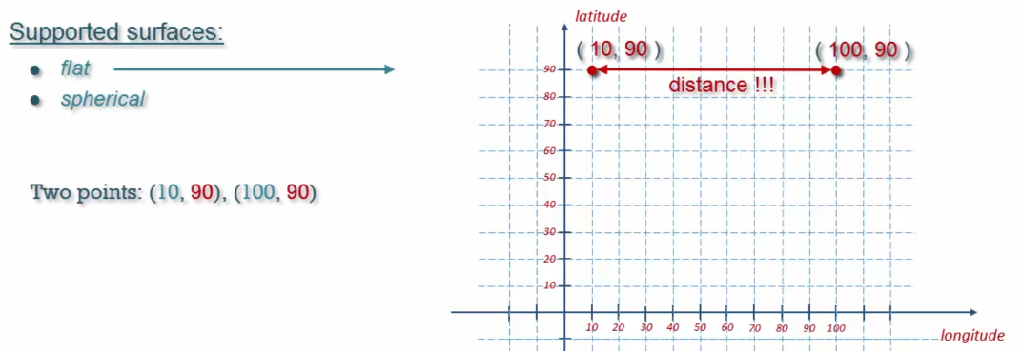

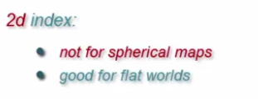

**How to specify coordinates in our document:**

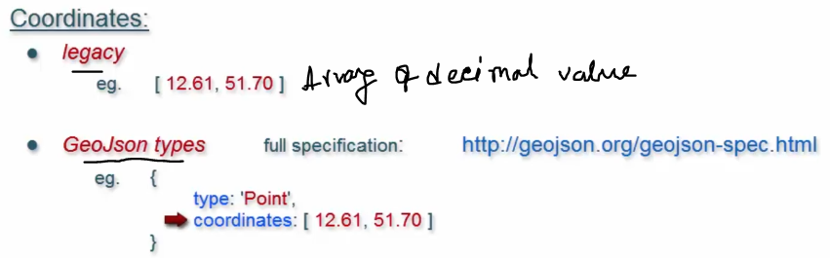

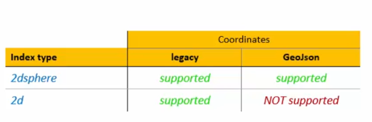 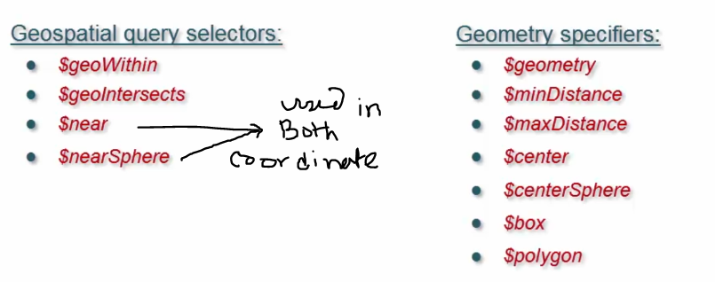

**Define 2d or flat coordinate:**

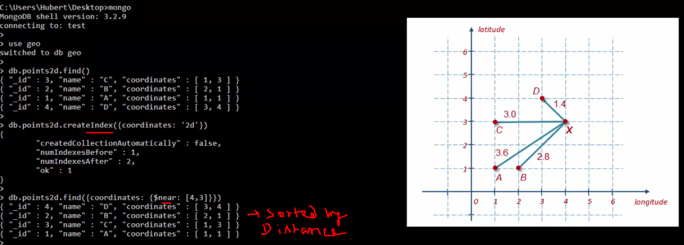

**$minDistance & $maxDistance:**

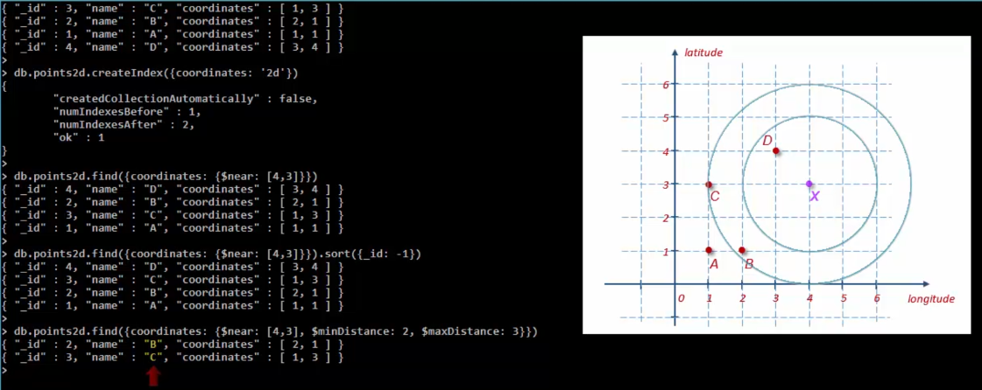

**$geoWithin, $center & $polygon:**

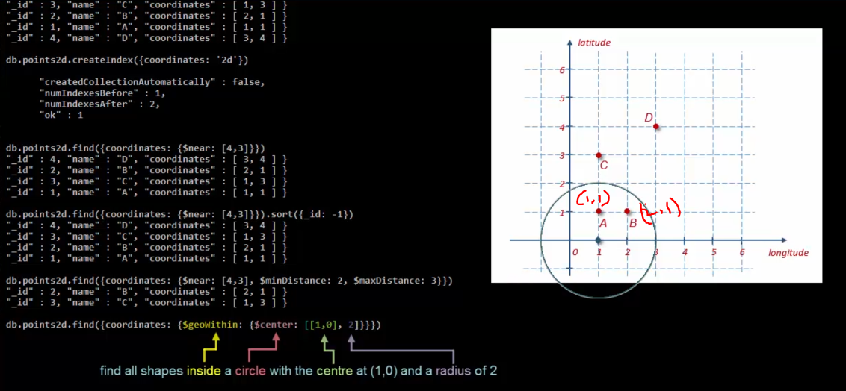

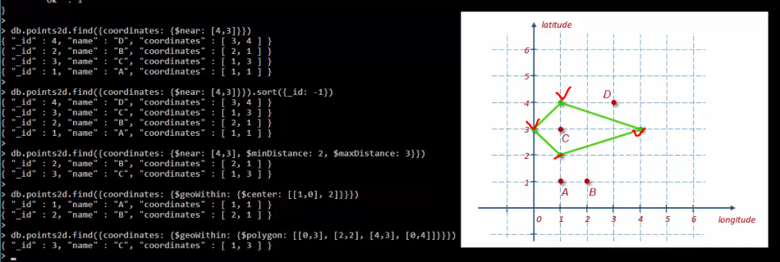

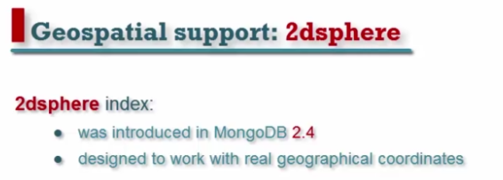

As ‘Location’ contain GeoJson type so we can create only 2dSphere index for coordinates.

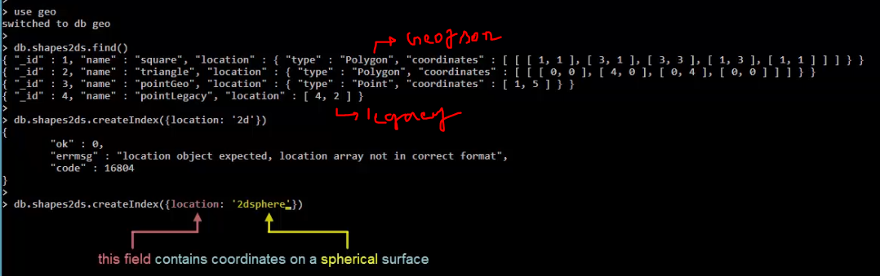

Different GeoJson types:-



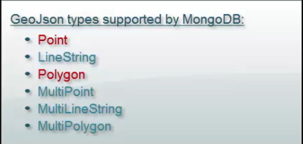

**$geoIntersects**

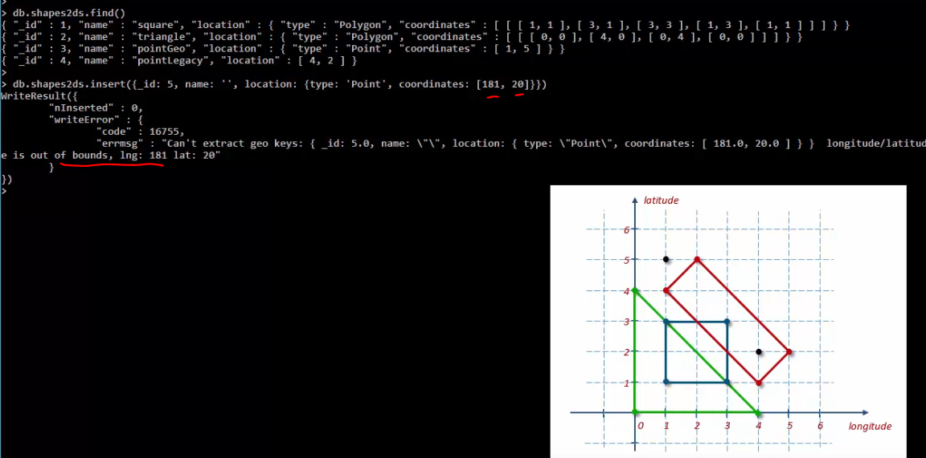

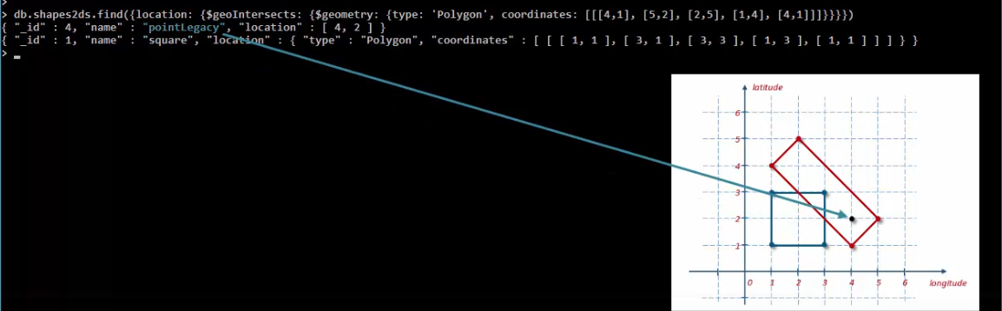

**Find closes capital from [12.16, 51.24]**

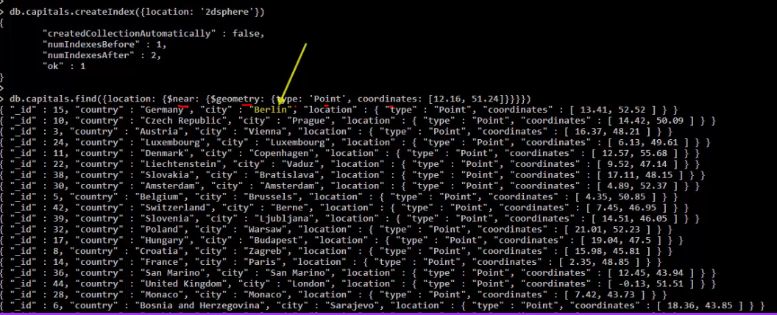

**27) MongoDB Aggregation?**

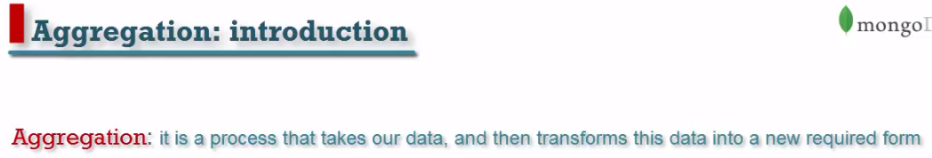 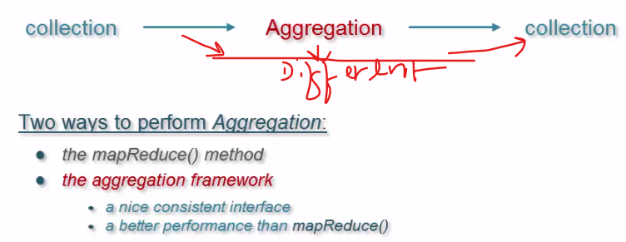



**How does it work?**

* To aggregate data, it defines a set of stages.
* Every set of stage perform operation on data. The result of one stage goes input to another stage.
* Set of stages are called **Aggregation pipeline**.
  + Tofind aggregation pipeline, use **aggregate** () to the collection and every document find one single stage.
  + To define single stage use various operator.

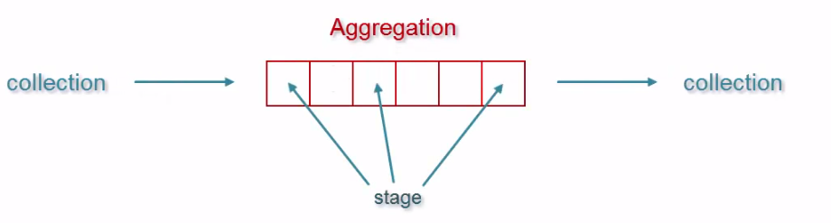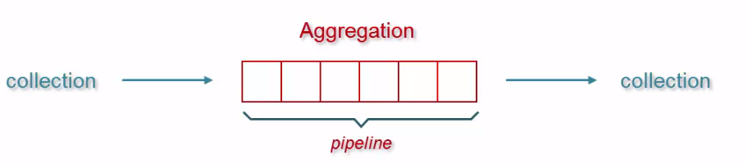

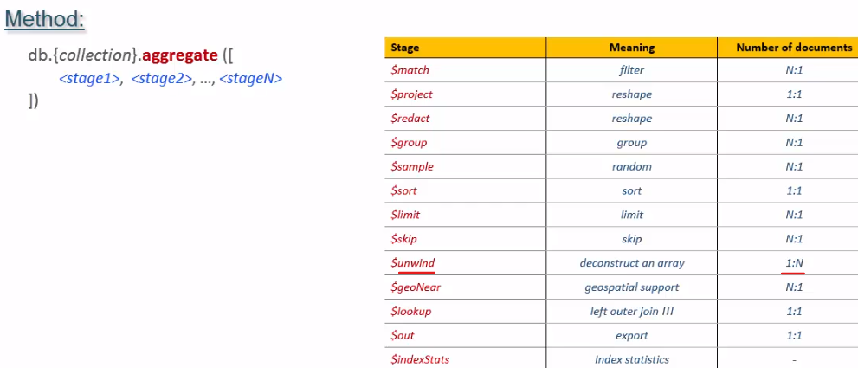

1. **$match**

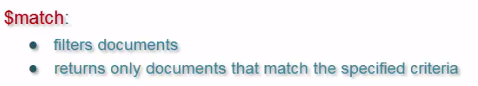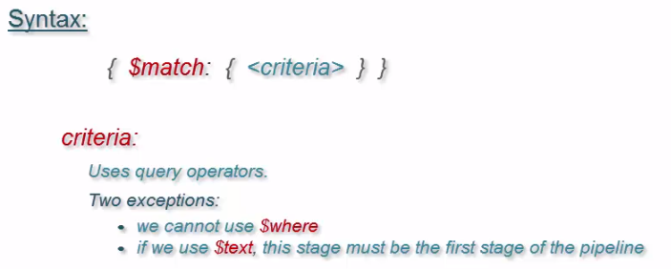

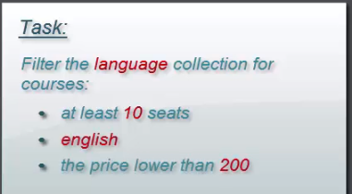

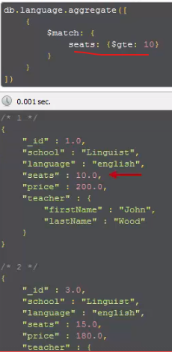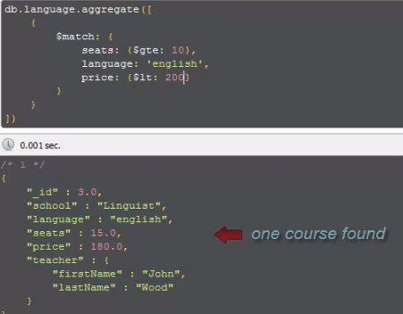

1. **$project**

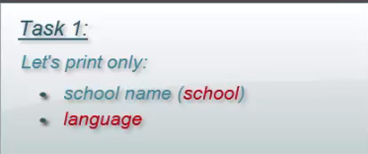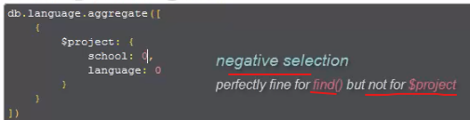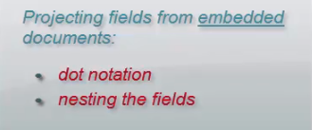

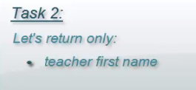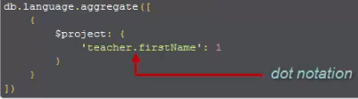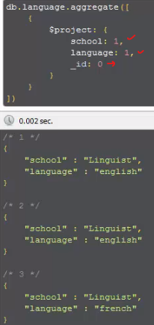

**Perform Expression using $project**

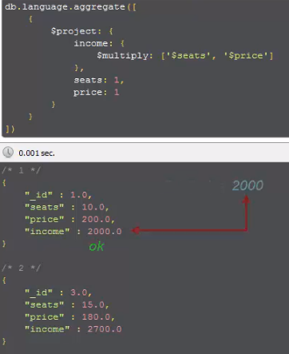

1. **$redact \*\***

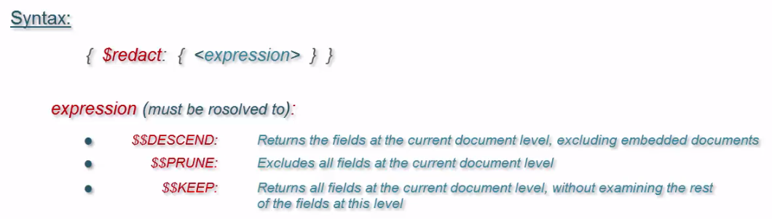

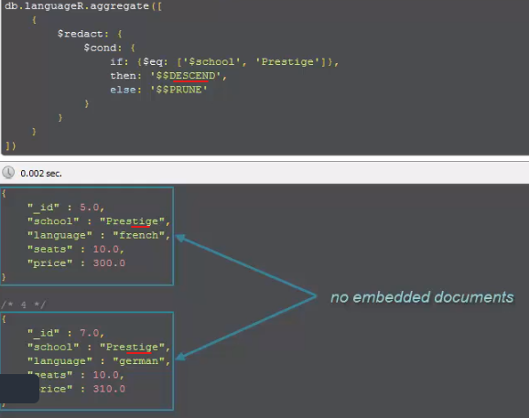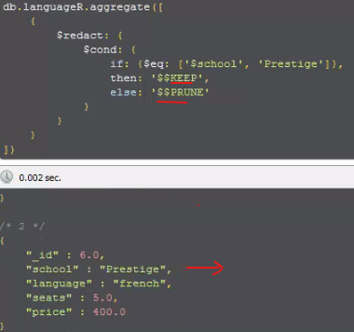

1. **$group \*\***

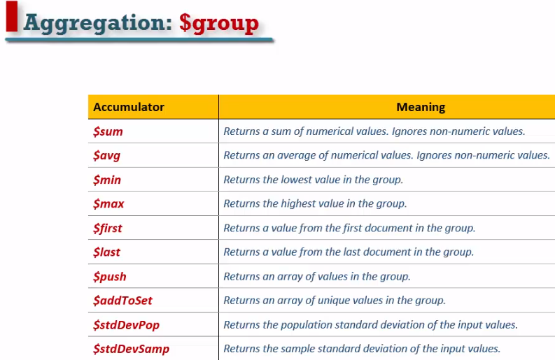

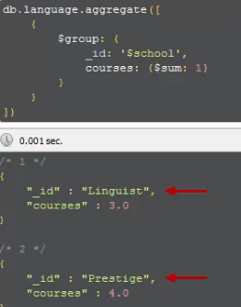**No of courses of each school 7 total no of seats in each school:**

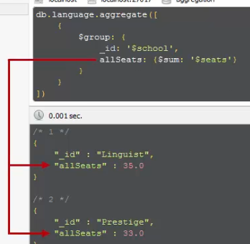 **Every language sum all seats, count no of courses, calculate avg seats:**

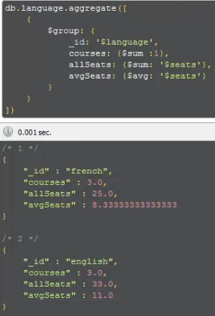

1. **$sort, $limit, $skip \*\***

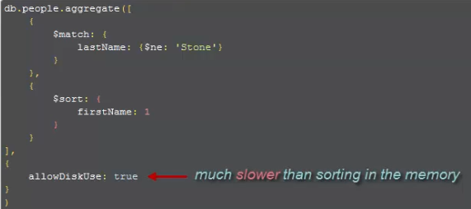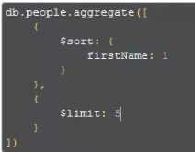

1. **$geoNear**
2. **$unWind**

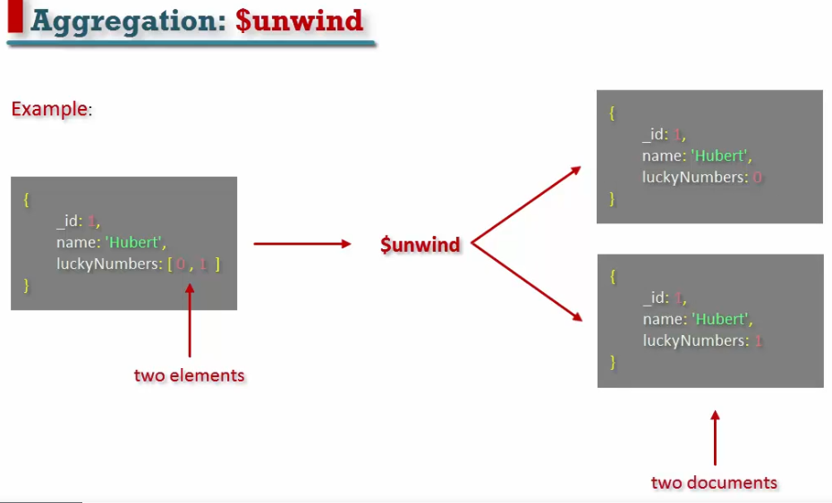

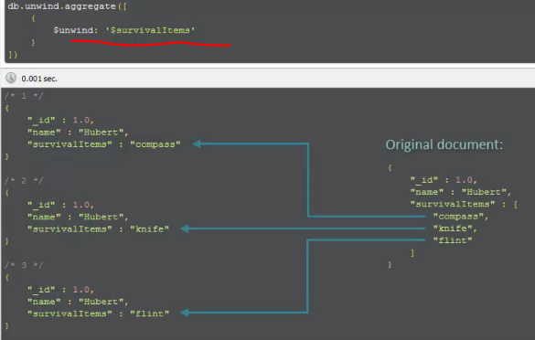

1. **$out**

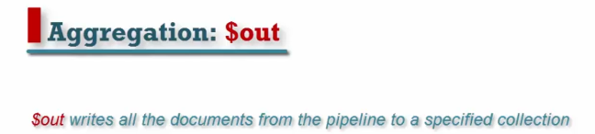

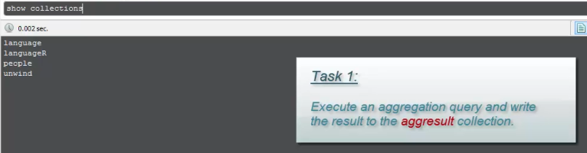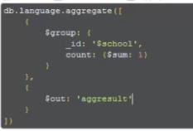

1. **$lookup**

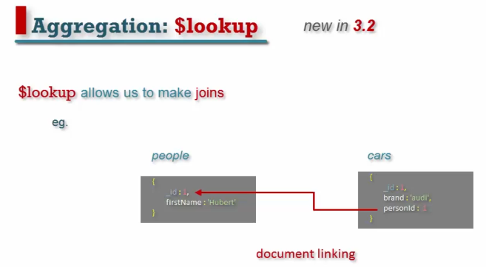

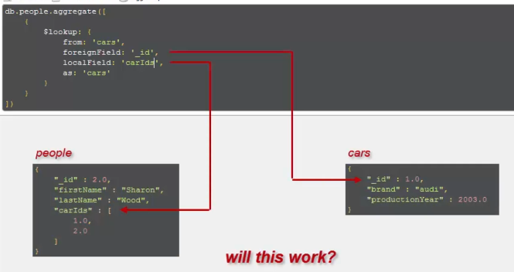

No. first unwind.

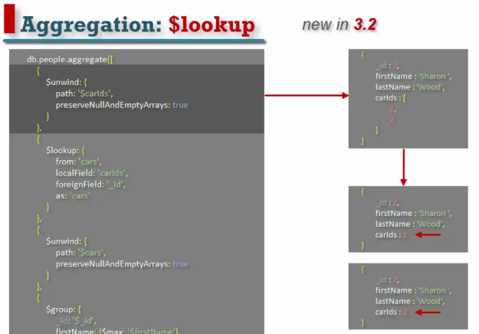

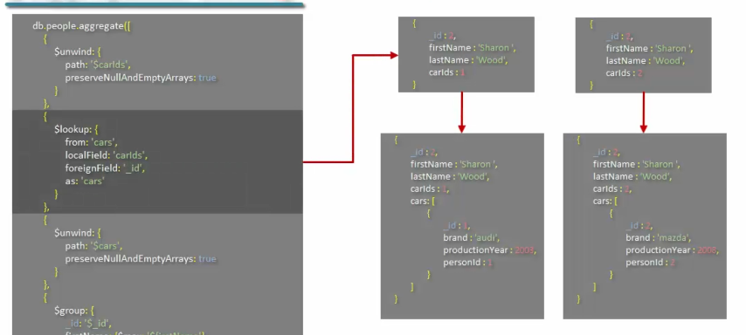

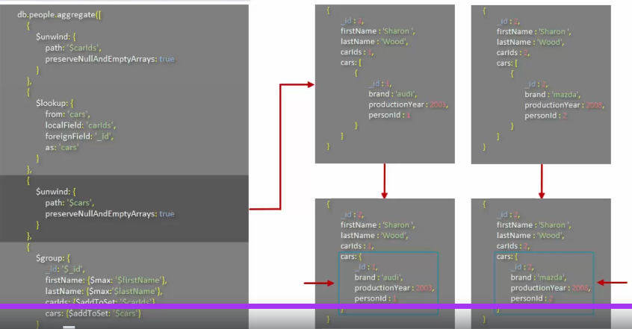

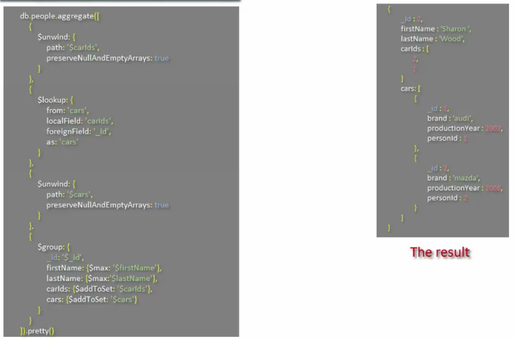

**27) MongoDB Replica set?**

It is a group of servers and every server contain same copy of data. If one of server crush so we don’t lose our data.

It provides: -

* Data durability
* High availability:- automatically handle server failure.

**Setting Up Replica Set: -**

* Create separate directory for every MongoDB instance:-

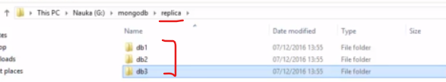

* Give name of each replica set using **replSet** command and provide port no 
* Create a configuration variable (create configuration.js on same directory) and provide host name, priority(to mark one of them as Primary replica set)

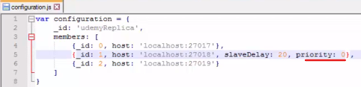

* Execute **rs.initiante**(configuration) on the server that is electable and can become a **new primary**.

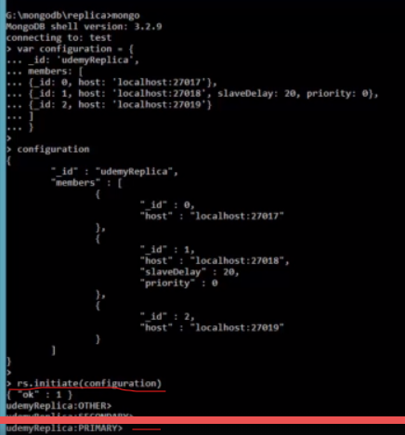

Voting Rule: - if two host are possible primaries.

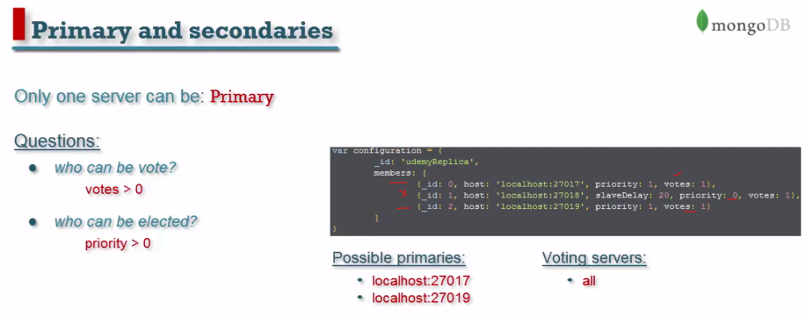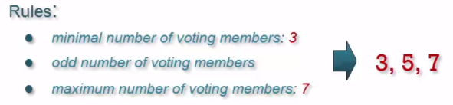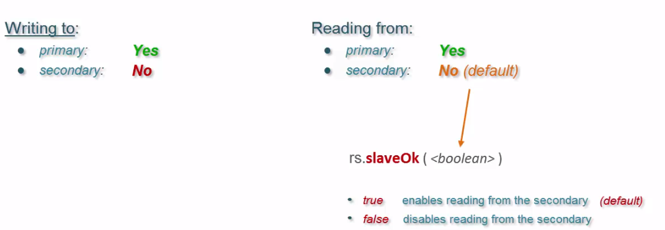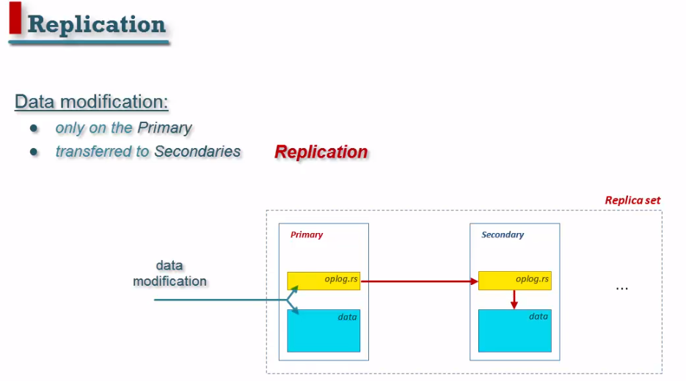

**Replication from primary to Secondary: -**

* **oplog.rs** collection is responsible for replicate data from primary to secondary server.
* oplog.rs is a **capped** collection.
* To write data from primary to secondary it takes some time. So immediate update not reflected on secondary server. called as eventually consistent.

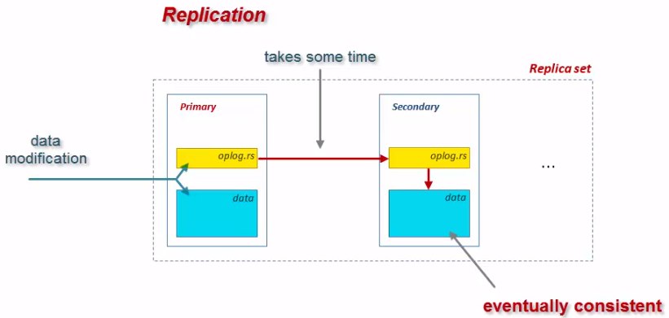 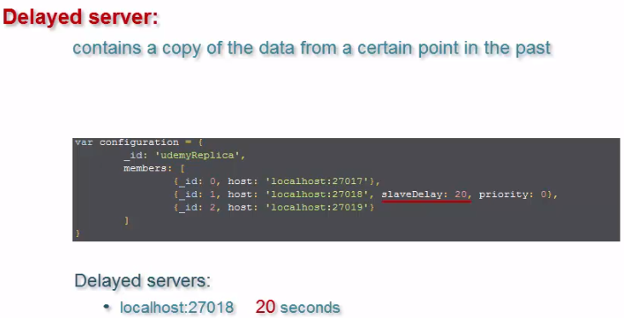

**Types of Members: -**

* Backup servers protect from **deadly queries**.
* Arbiter member mainly use for **voting** primary server.
* Check replica set status by **rs.status()**

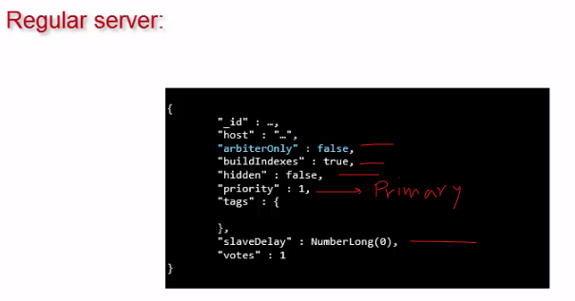 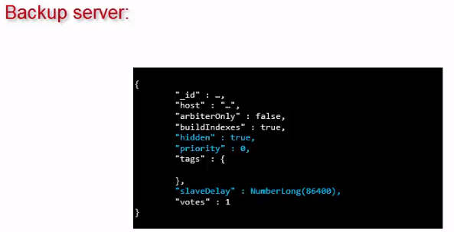

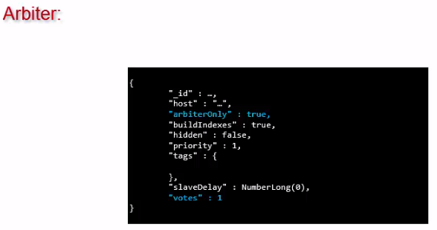 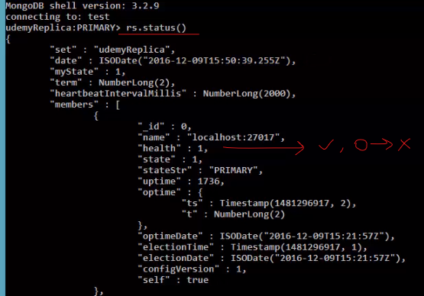

**Automatic failure: -**

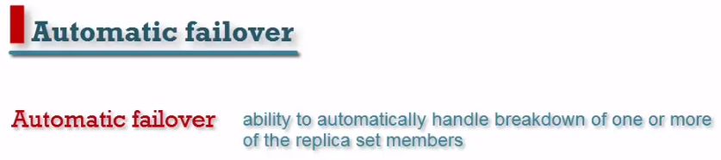

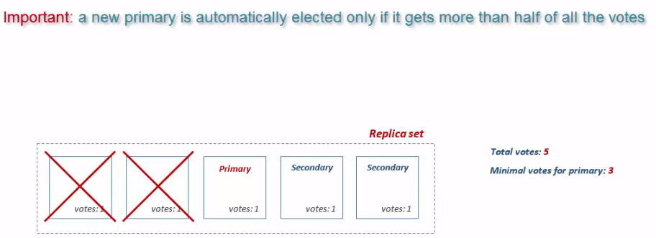

* Remember that if we have 3 member and one of them get fail so Primary will convert into Secondary and cannot modify our data.

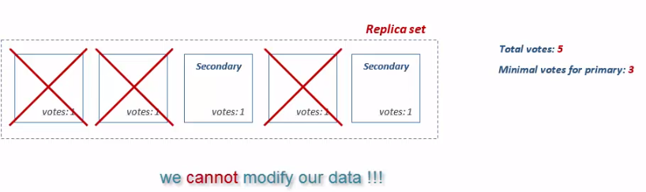

**Application working with Replica set: -**

* To avoid connection failure must connect to multiple replicas set.
* In python use below code

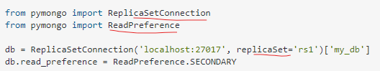

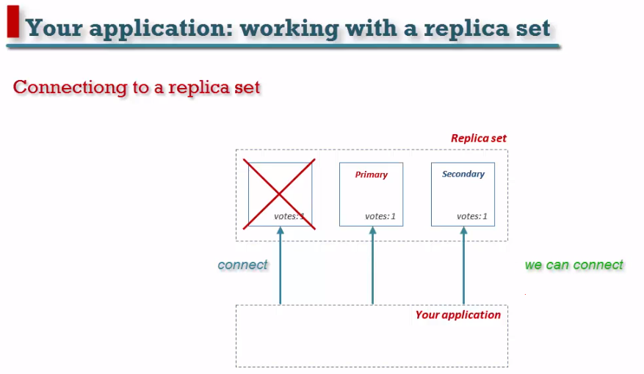 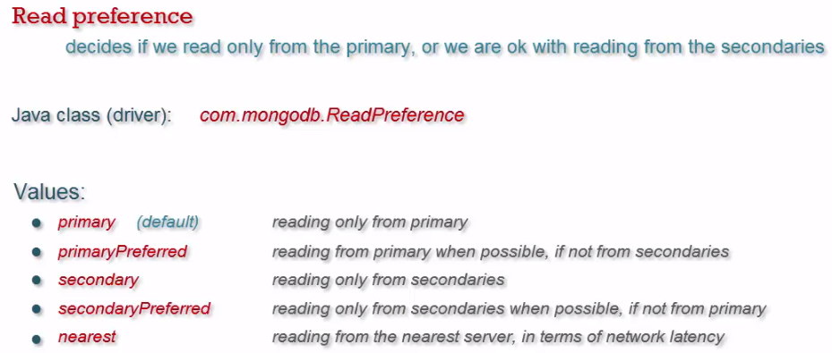

**Designing Replica set: -**

* Never create a replica set that consist of two members. No primary is available, and we cannot write.

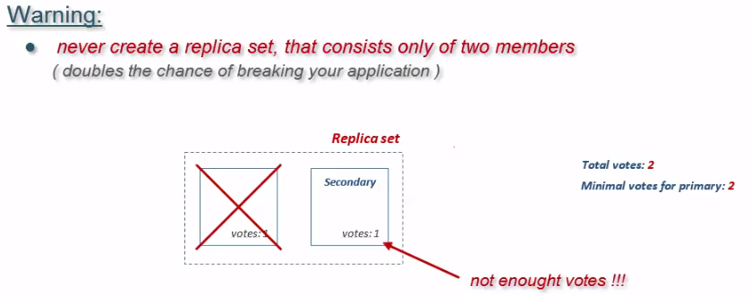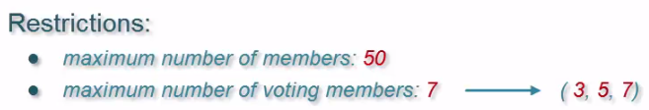

* We can add Arbiter if there is an even number of replica set.

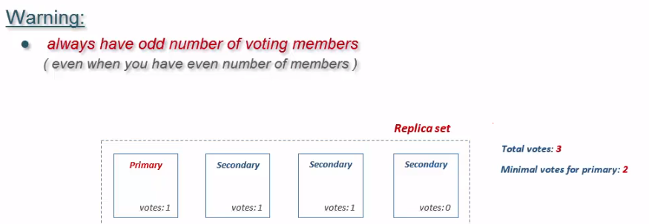

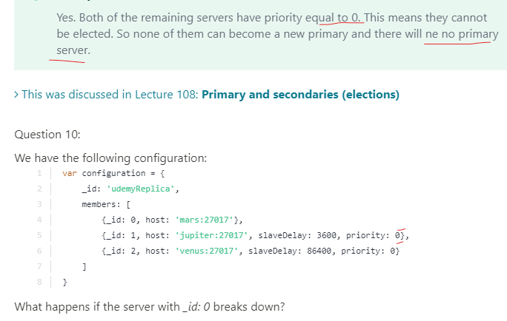

**28) MongoDB Schema design?**

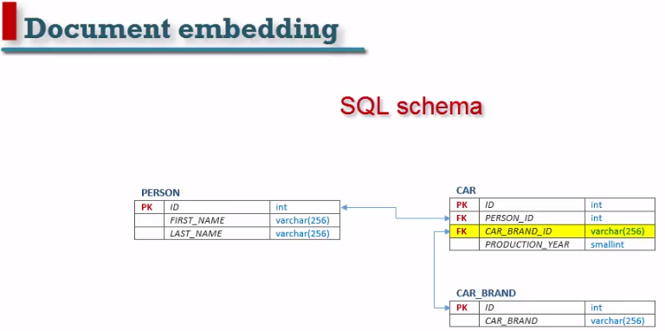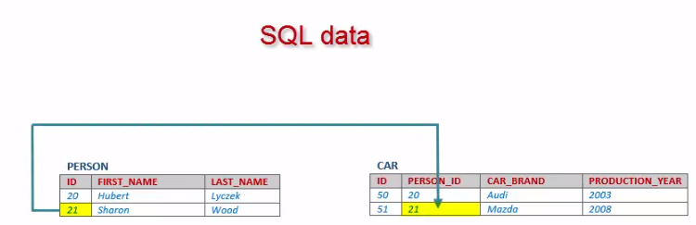

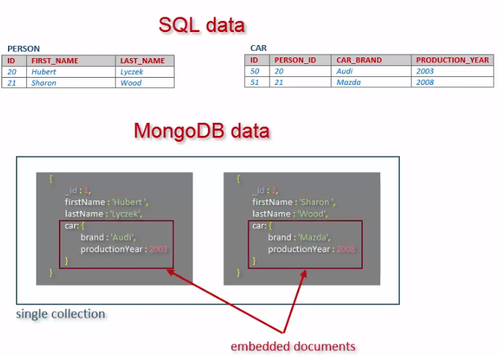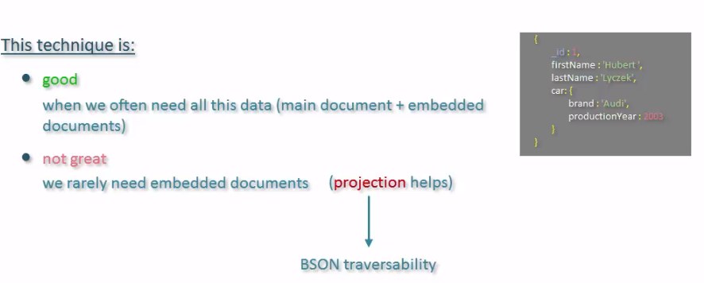

* Create two collections and linked between them.
* In MongoDB does not support constraint like RDMS.

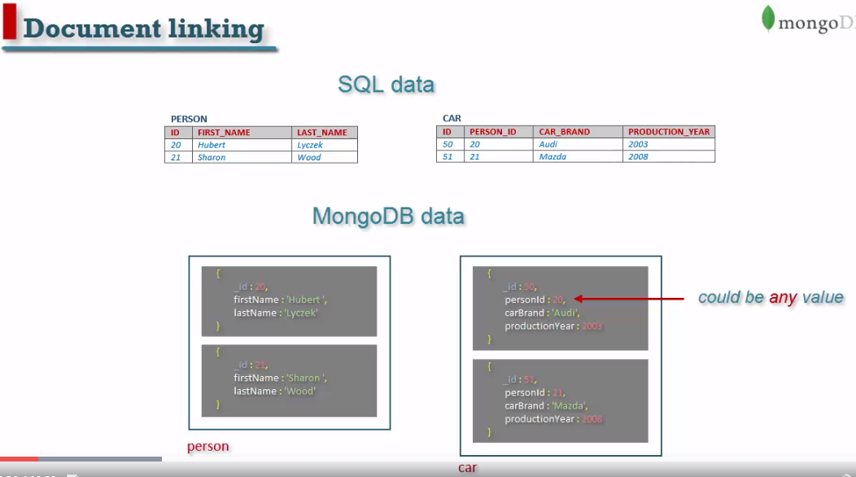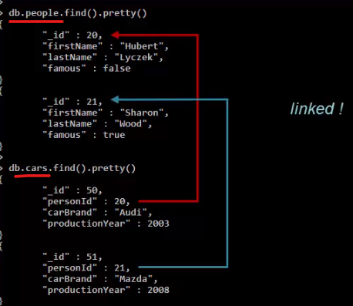

* **Find person name Hubert car**
* **Find people with cars**

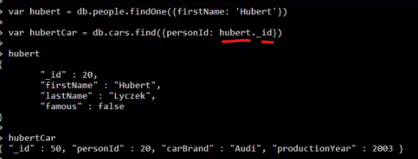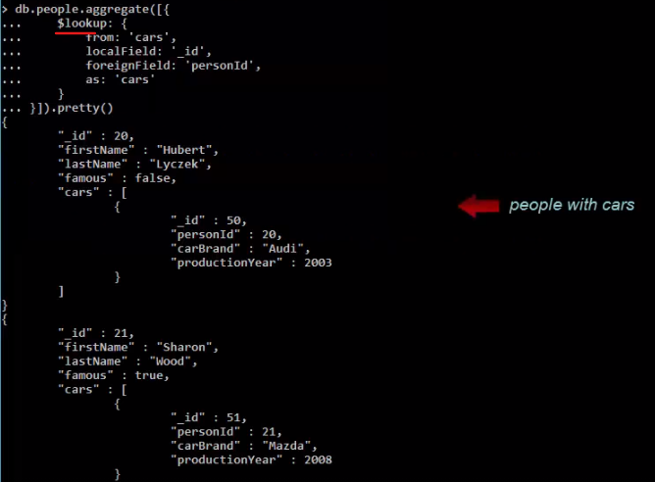

* Cannot modify **more than one** document in one transaction.
* It is useful for **many to many** relationships.
* By using document linking reads can be done using **single request**.
* Document reads still be **slower**.

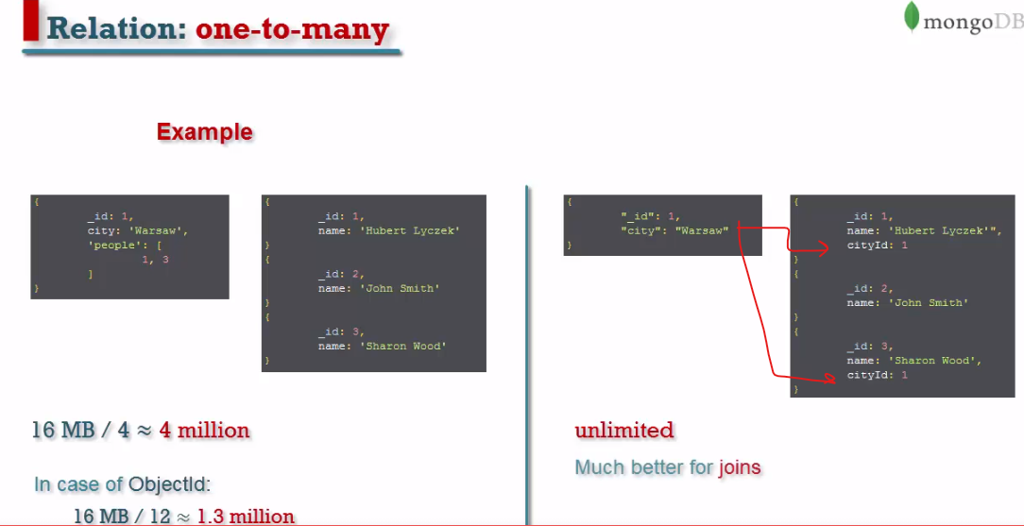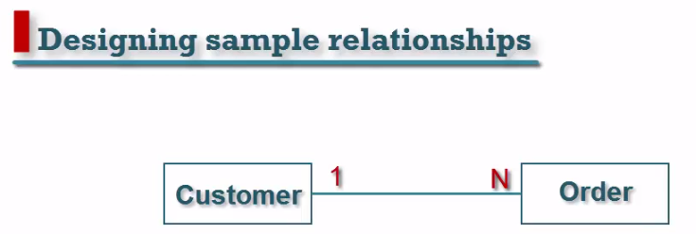

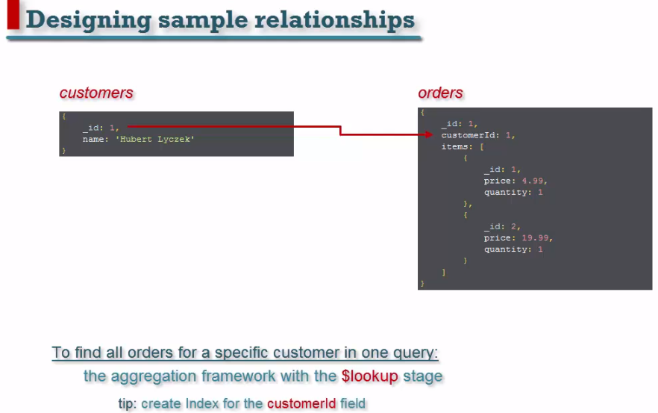

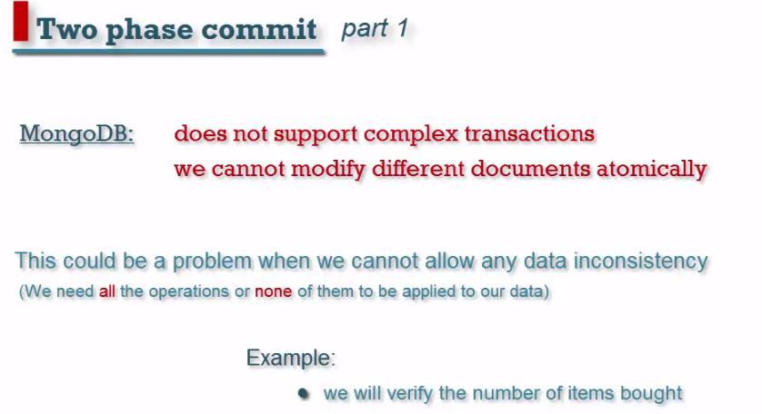

**49) What are the elements of the Sharded Cluster?**

Following are the elements of the Sharded Cluster:

* Query routers
* Shards
* Config servers

**50) How does MongoDB provide consistency?**

MongoDB uses the **reader–writer** locks, allowing simultaneous readers to access any supply like a database or a collection but always offering private access to single writes.

**51) How can you isolate the cursors from intervening with the write operations?**

The **snapshot()** method is used to isolate the cursors from intervening with writes. This method negotiates the index and makes sure that each query comes to any article only once.

**52) What is the use of Journaling in MongoDB?**

Journaling is used for safe backups in MongoDB.

**53) Which command is used to see a connection?**

We can use the following command to see the connection:

**>db_adminCommand (“connPoolStats”)**

**54) What is Storage Encryption?**

Storage encryption encrypts all MongoDB data on storage or on the operating system to ensure that only authorized processes can access the protected data.

**55) What is Replica set oplog?**

The **oplog** records all operations that modify the data in the replica set.

**56) What is the syntax of the skip() method?**

The syntax of the skip() method is as follows:

>**db.COLLECTION_NAME.find().limit(NUMBER).skip(NUMBER)**

**57) What is the use of the dot notation in MongoDB?**

MongoDB uses the dot notation to **access the elements of an array** and the fields of an embedded document.

**58) Does MongoDB push the writes to disk immediately or lazily?**

MongoDB pushes the data to disk lazily. It updates the immediately written to the **journal** but writing the data from journal to disk happens **lazily**.

**59) Mention the command to list all the indexes on a particular collection.**

**db.collection.getIndexes()**

**60) What is the role of a profiler in MongoDB? Where does the writes all the data?**

The database profiler collects data about MongoDB write operations, cursors, database commands on a running mongod instance. You can enable profiling on a per-database or per-instance basis.

The database profiler writes all the data it collects to the **system.profile collection**, which is a **capped** collection.

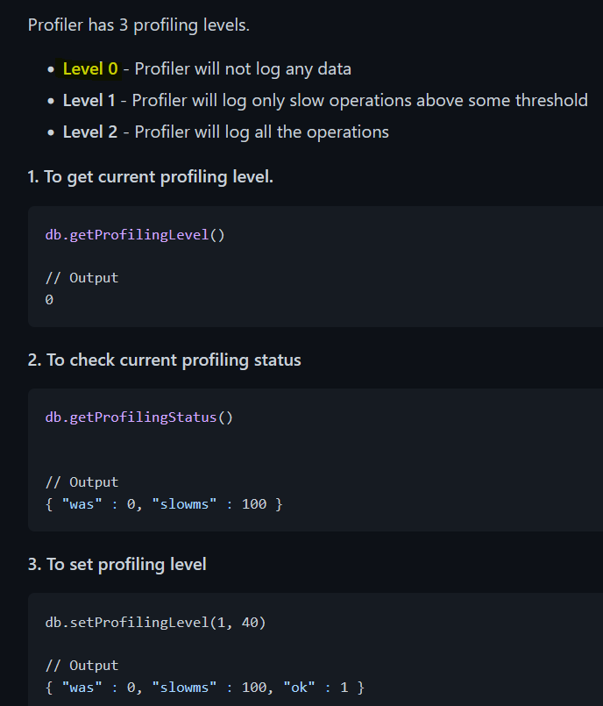

**61) Mention the command to check whether you are on the master server or not?**

**db.isMaster()**

**62) Can one MongoDB operation lock more than one database? If yes, how?**

Yes. Operations like **copyDatabase()**, **repairDatabase()**, etc. can lock more than one database involved.

**63) Which command can be used to provide various information on the query plans used by a MongoDB query?**

The **explain()** command can be used for this information. The possible modes are: 'queryPlanner', 'executionStats', and 'allPlansExecution'.

**64) How do we control the MongoDB Performance?**

We can control the MongoDB Performance by:

* Locking the Performance
* Identifying the number of connections
* Database Profiling
* Full-time Diagnostic Data Capture

**65) How can we sort the user-defined function? For example, x and y are integers, and how do we calculate “x-y”?**

**66) Are null values allowed?**

Yes, but only for the members of an object. A null cannot be added to the database collection as it isn’t an object. But {}can be added.

**67) Should you start out with Sharded or with a Non-Sharded MongoDB environment?**

We suggest starting with non-Sharded for **simplicity** and **quick startup**, unless your initial data set will **not fit on single servers**. Upgrading to Sharded from Non-sharded is easy and seamless, so there is not a lot of advantage in setting up Sharding before your data set is **large**.

**68) How does Sharding work with replication?**

Sharding is a method for distributing data across multiple machines.

*Vertical Scaling* involves increasing the capacity of a single server, such as using a more powerful CPU, adding more RAM, or increasing the amount of storage space. Limitations in available technology may restrict a single machine from being sufficiently powerful for a given workload.

*Horizontal Scaling* involves dividing the system dataset and load over multiple servers, adding additional servers to increase capacity as required.

Sharding is a way to horizontally scale our database.

Each Shard is a **logical collection of partitioned data**. The shard could consist of a **single** server or a cluster of **replicas**. Using a **replica set for each Shard** is highly recommended.

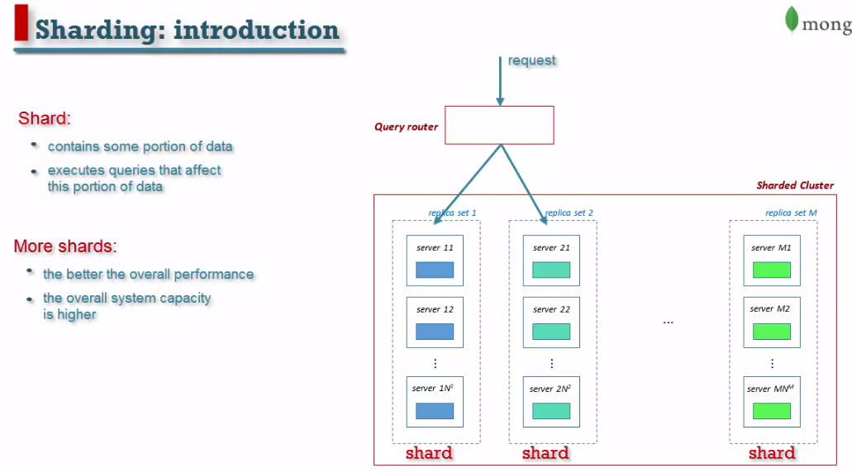

Query Router is a simple Mongos. It uses **config server** that **holds Sharded cluster meta data**. Based on this meta data our query server knows where to **send query**.

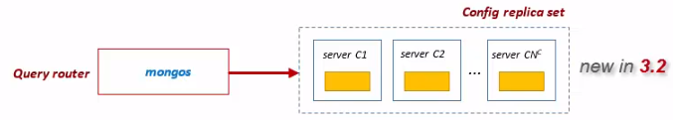 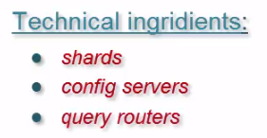



All data base collections are stored in it and responsible to distribute across existing shard.

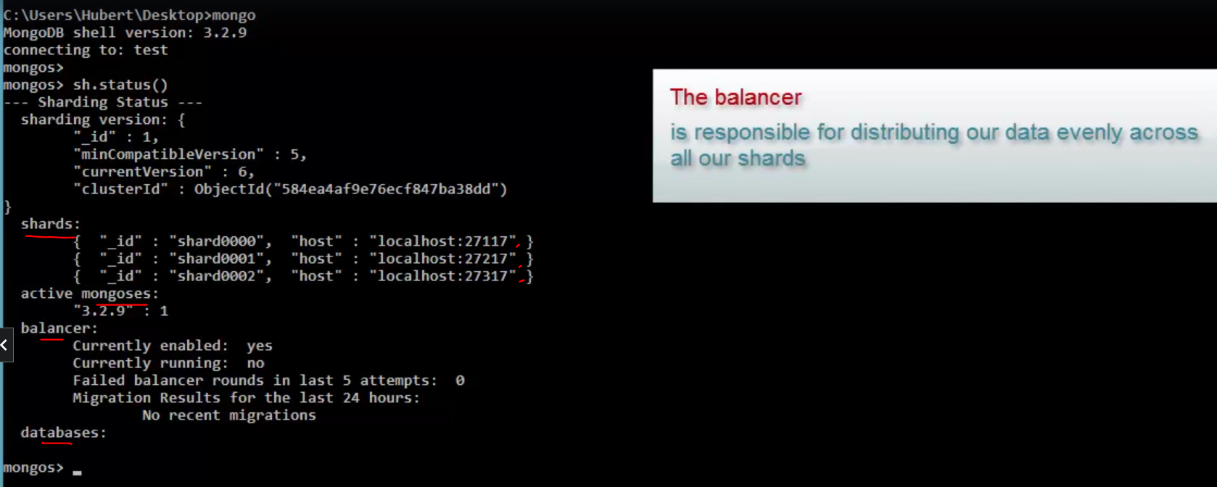



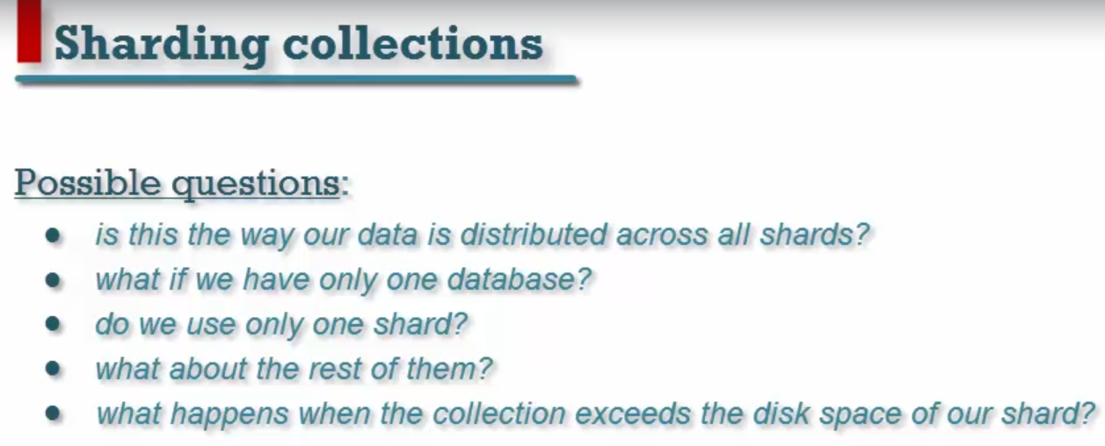

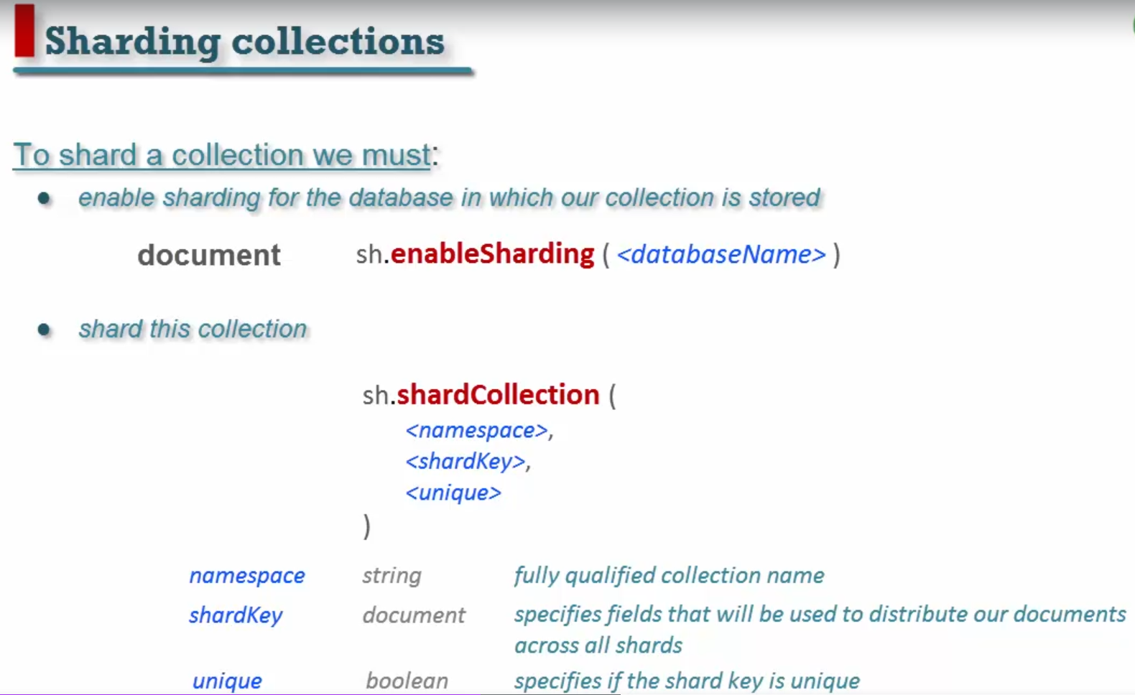

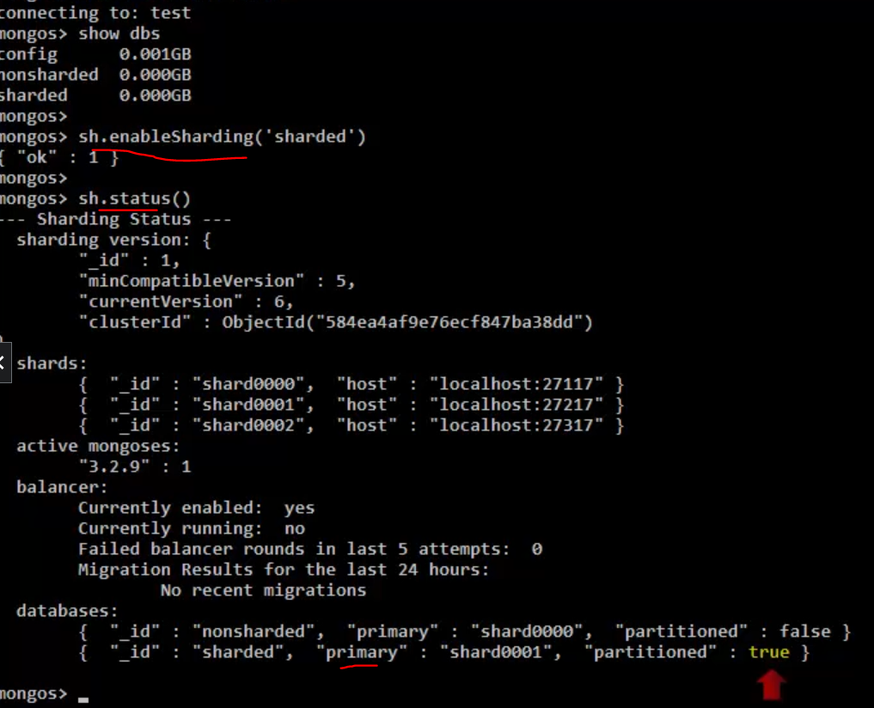

Shard **test** collections: -

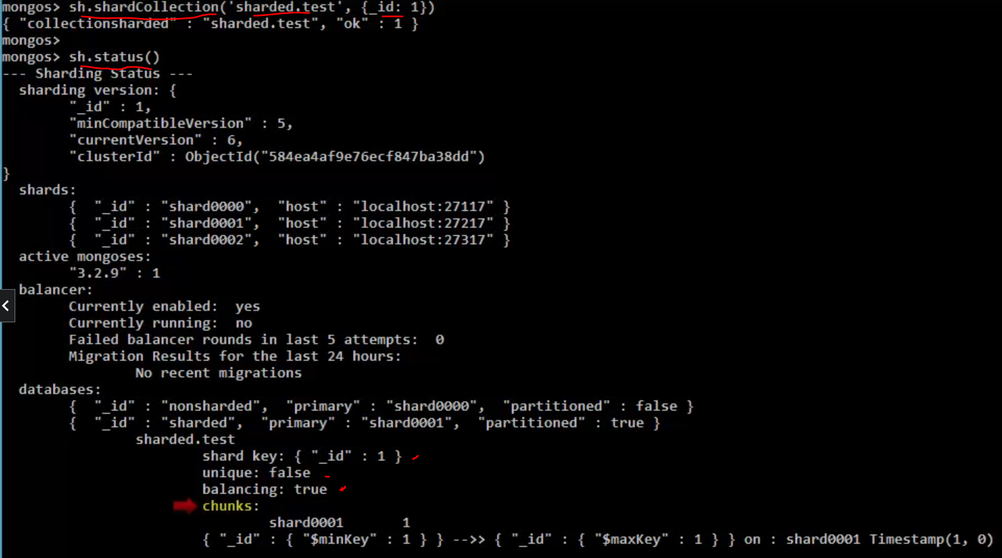

Every Shard is divided into smaller parts which are called **Chunks.** It contains many documents and every chunk is distributed equally to every shard by balancer.

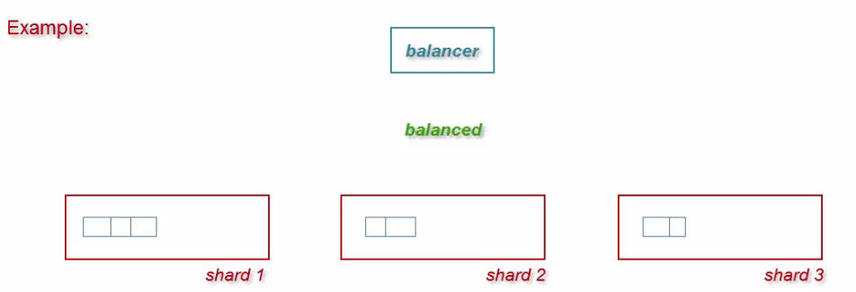

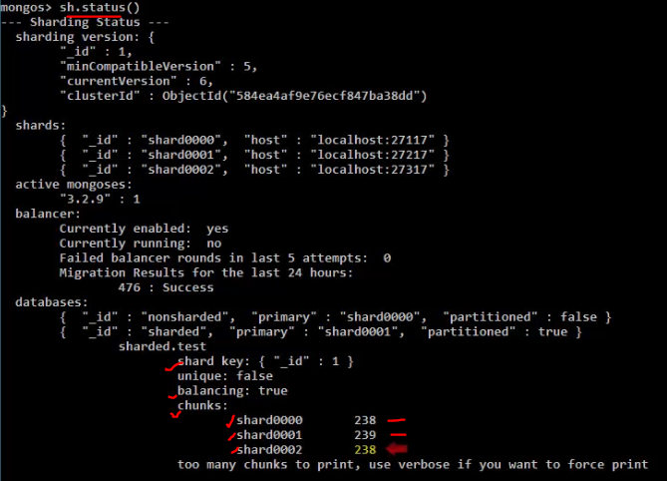

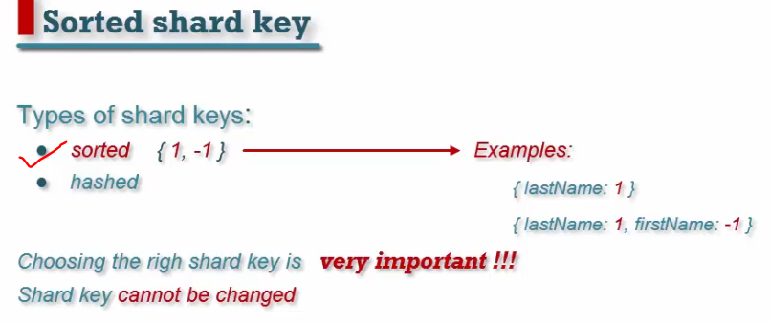

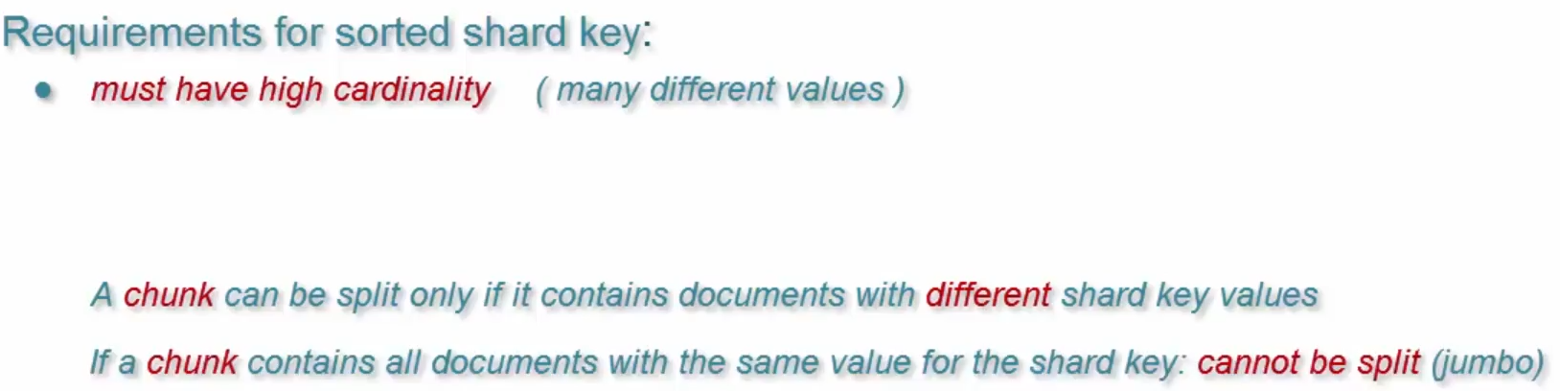

**68) Copy collection & rename collections?**

db.collection1.aggregate([

{

$match: {}

},

{ $out: "collection2"

}])

**Execution time:** 15s  
**Pros:**  
**+** Very fast.  
**+** Usability: 4.  
**Cons:**  
**-** Can clone collection to the same database only.  
**-** Doesn't copy **collection properties and indexes**.

db.originalCollectionName.renameCollection('newCollectionName')

db.people.renameCollections(‘NewPeople’)